**Configurable Solr Search component for Sitecore 9.2**

Mhasasneh-SearchUI is a configurable Solr Search component for Sitecore 9.2 that can allow the developer to run solr search queries without writing code by using set of settings and operators in Sitecore tree.

### Built With

Solr Search component tested with the following versions:

* [Sitecore9.2](https://dev.sitecore.net/Downloads.aspx)
* [Sitecore Experience Accelerator 1.9.0 rev. 190528 for 9.2](https://dev.sitecore.net/Downloads.aspx)
* [Solr](https://github.com/jaffal83/TripleM-SearchUI/blob/develop/solr-8.2.0) 8.2

**How to Install the module to Sitecore 9.2?**

1- open the Content Management admin dashboard   
  
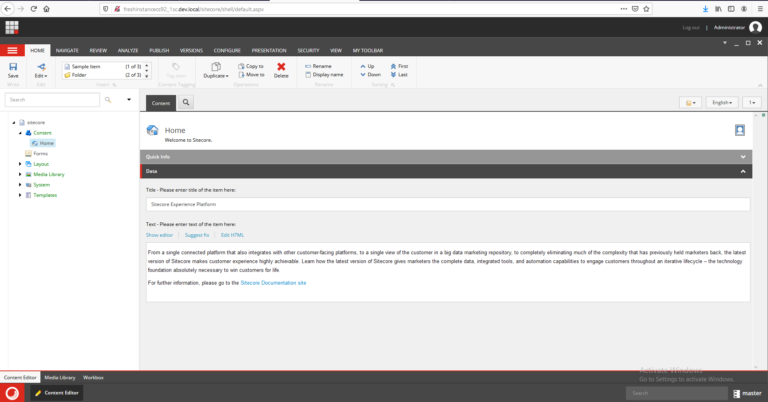

2- Navigate to installation wizard

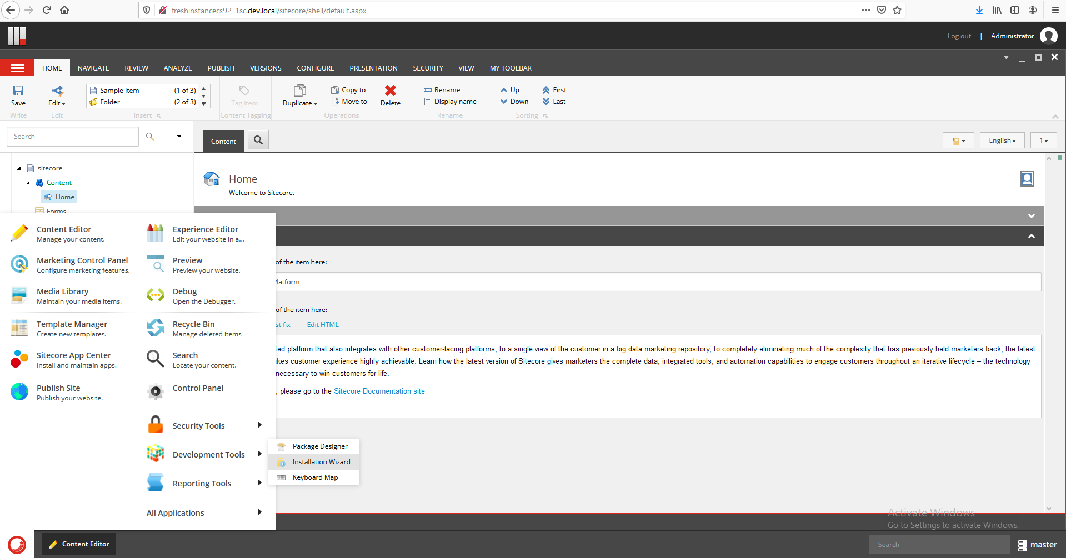

3-Upload the module package “Mhasasneh SearchUI-1.0.0.zip”

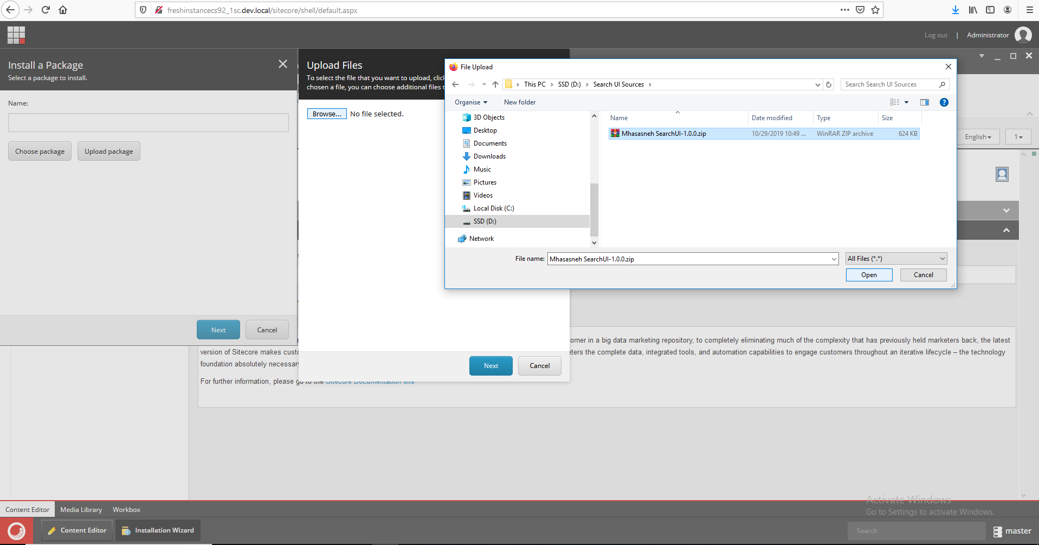

4-Press next and install

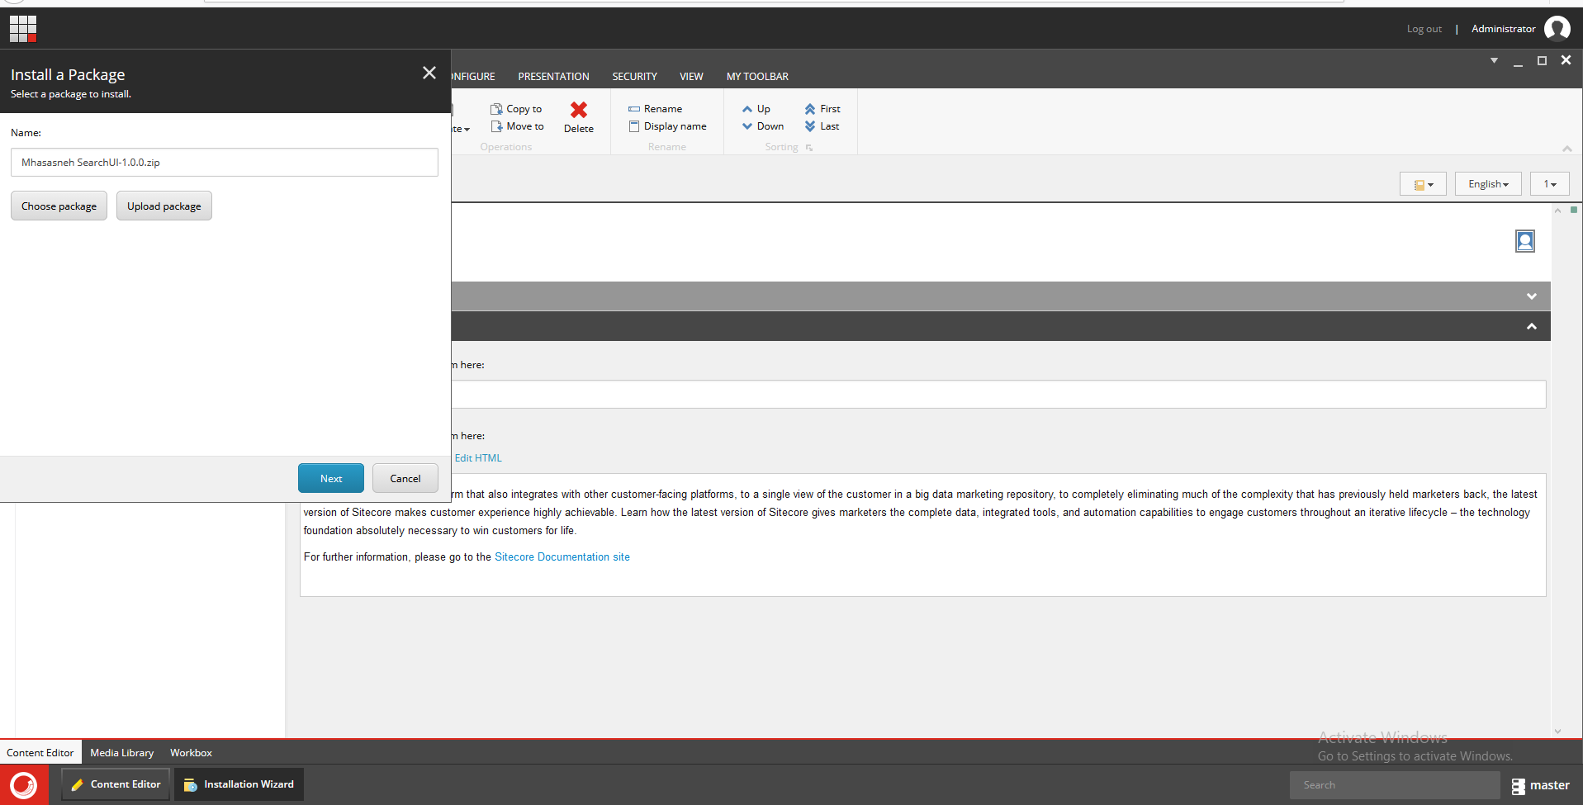

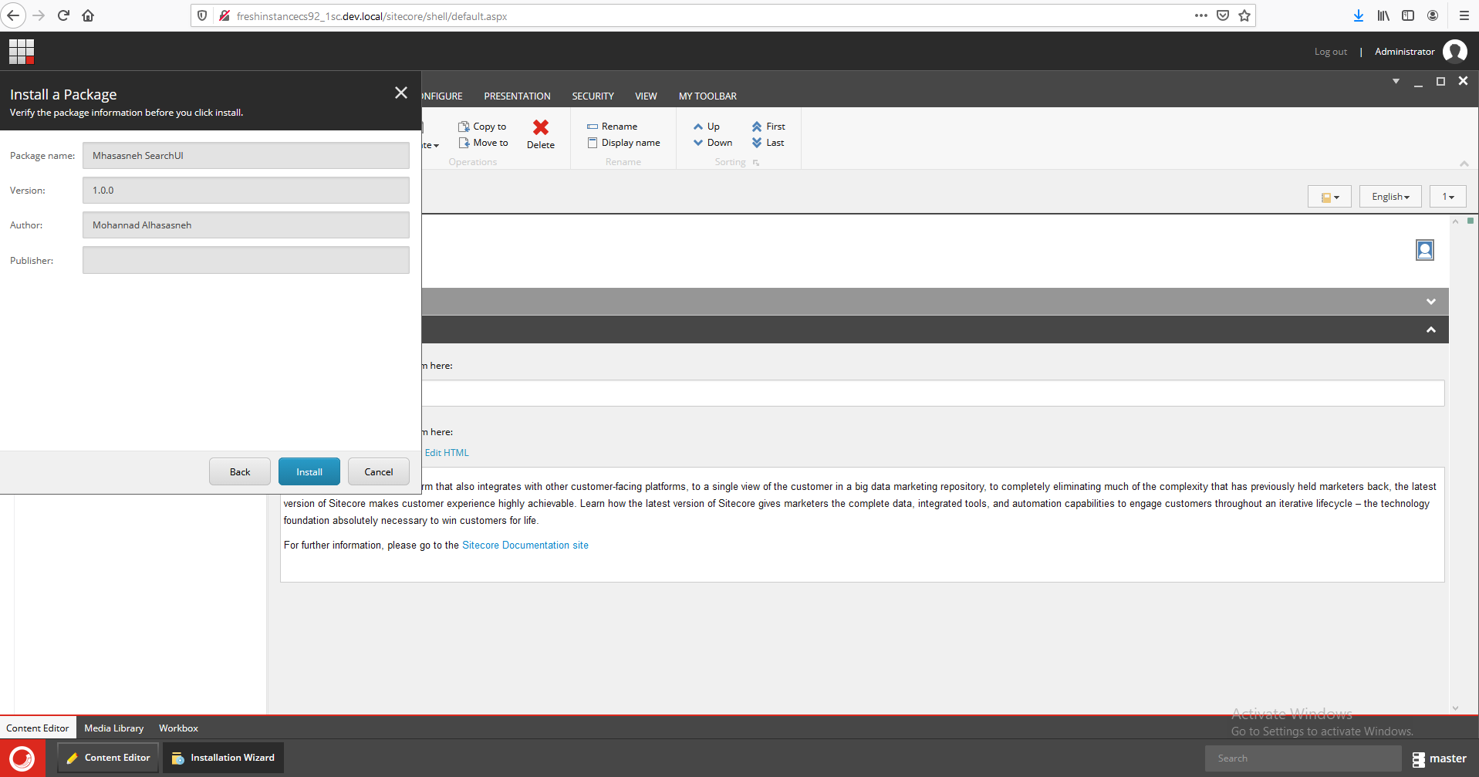  
  
5- If you got this message just press No  
  
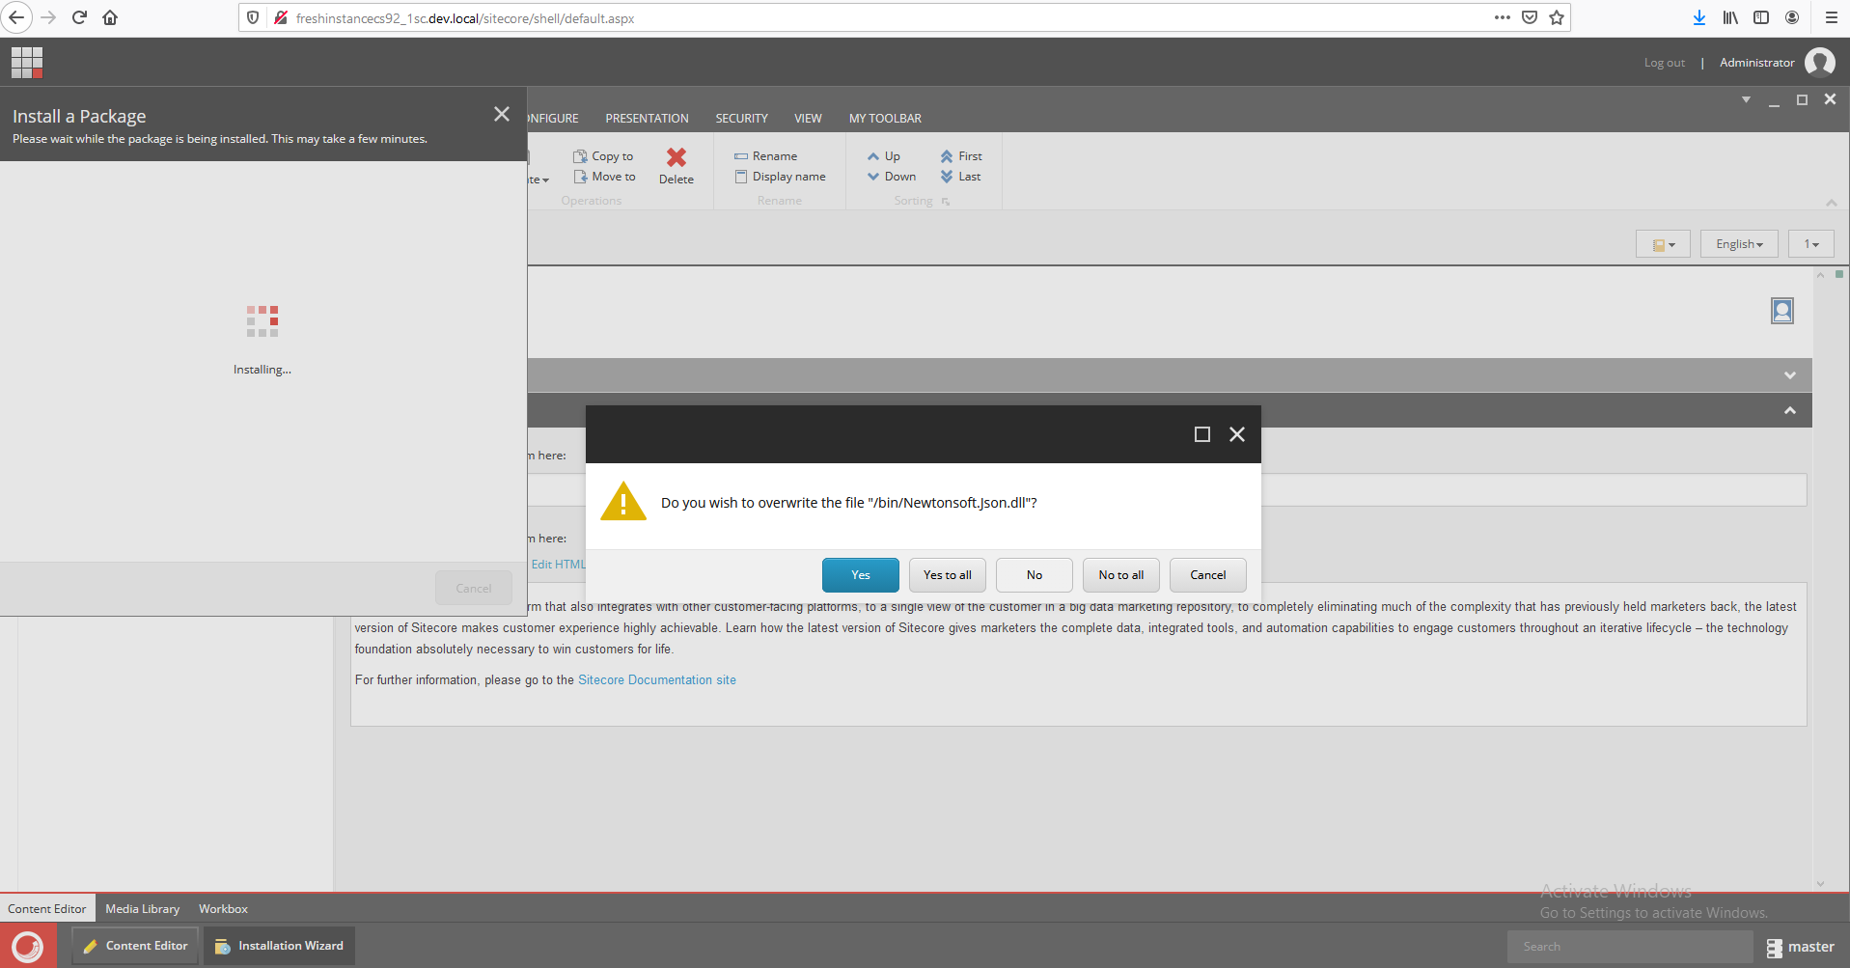  
  
6- Done ☺ , you should see the following Settings items in your instance template tree  
  
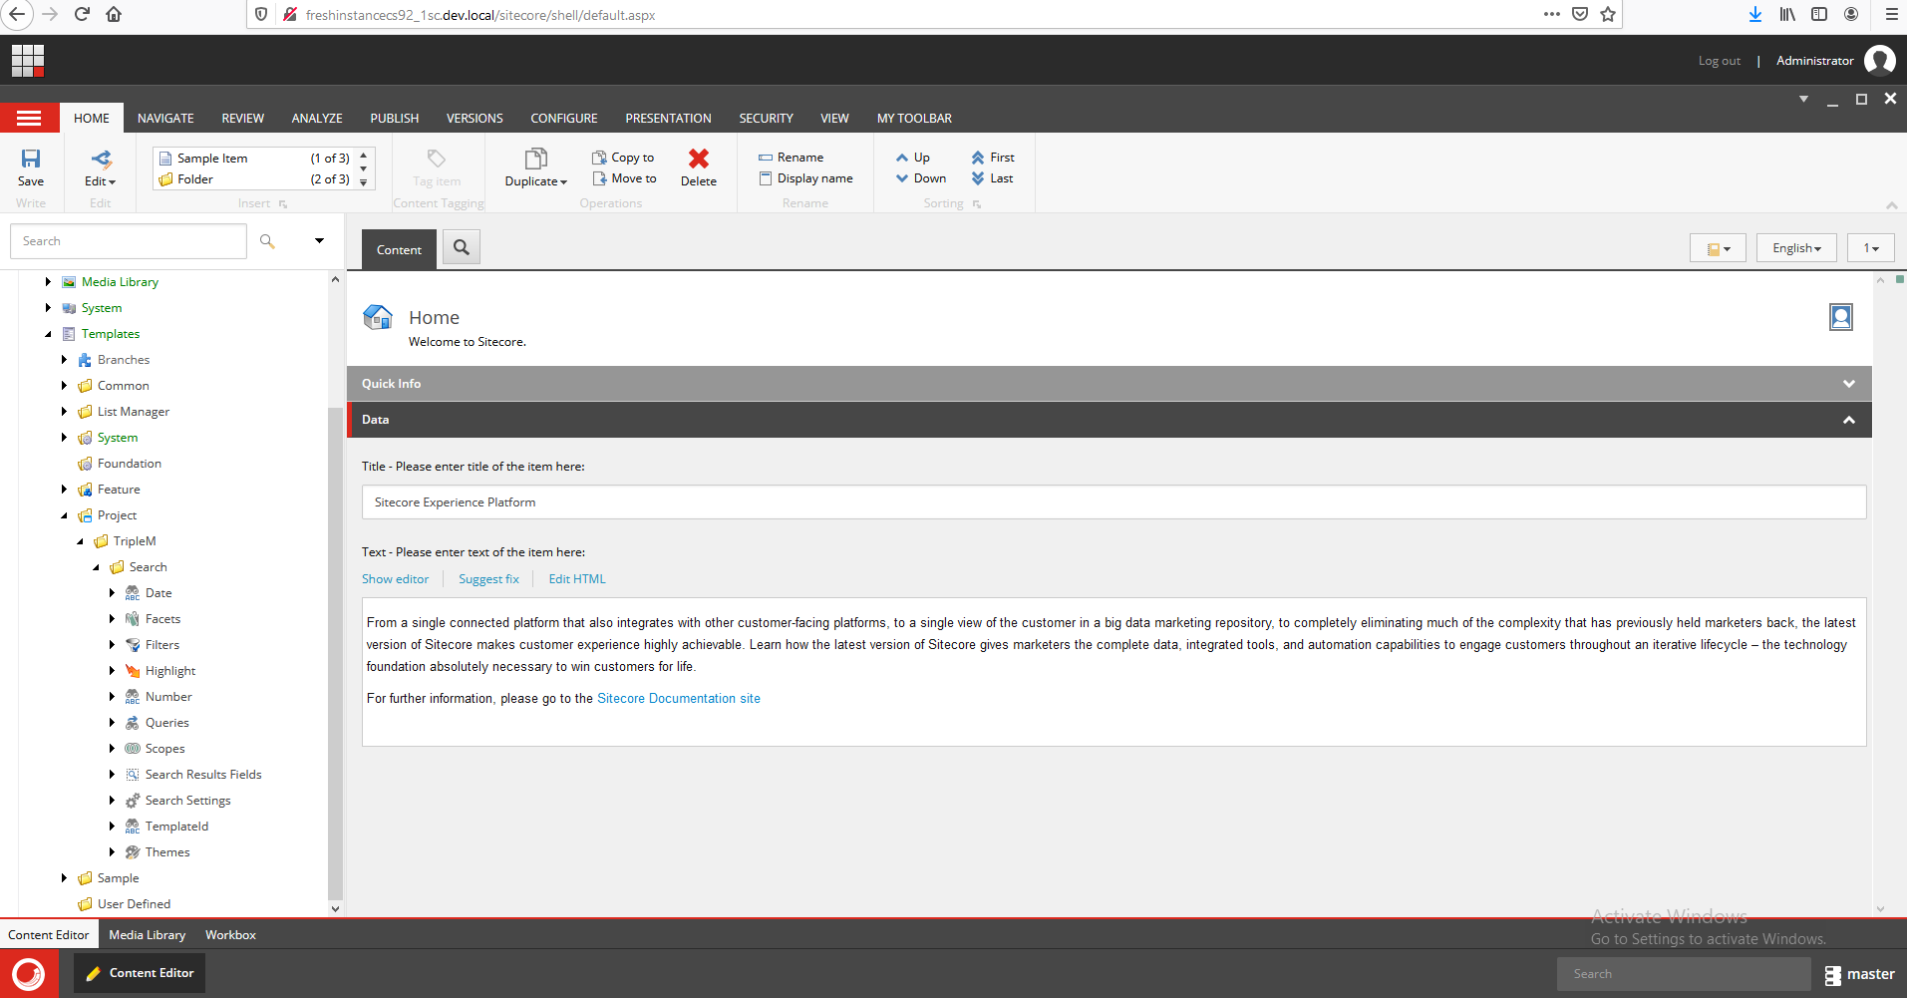  
  
  
  
How to use the Solr search module ?  
  
1-Create new search setting item

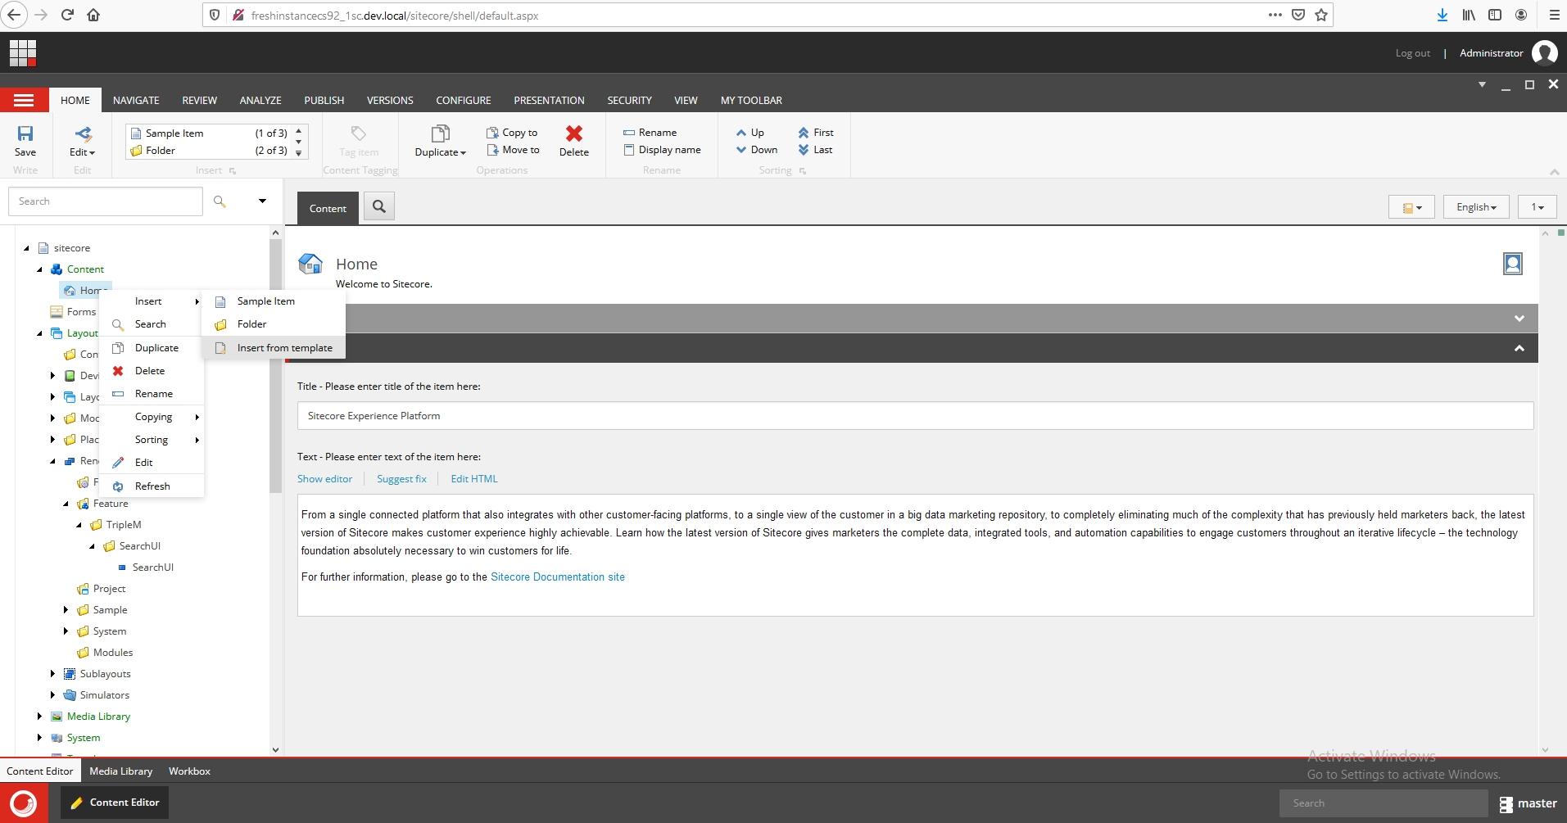  
  
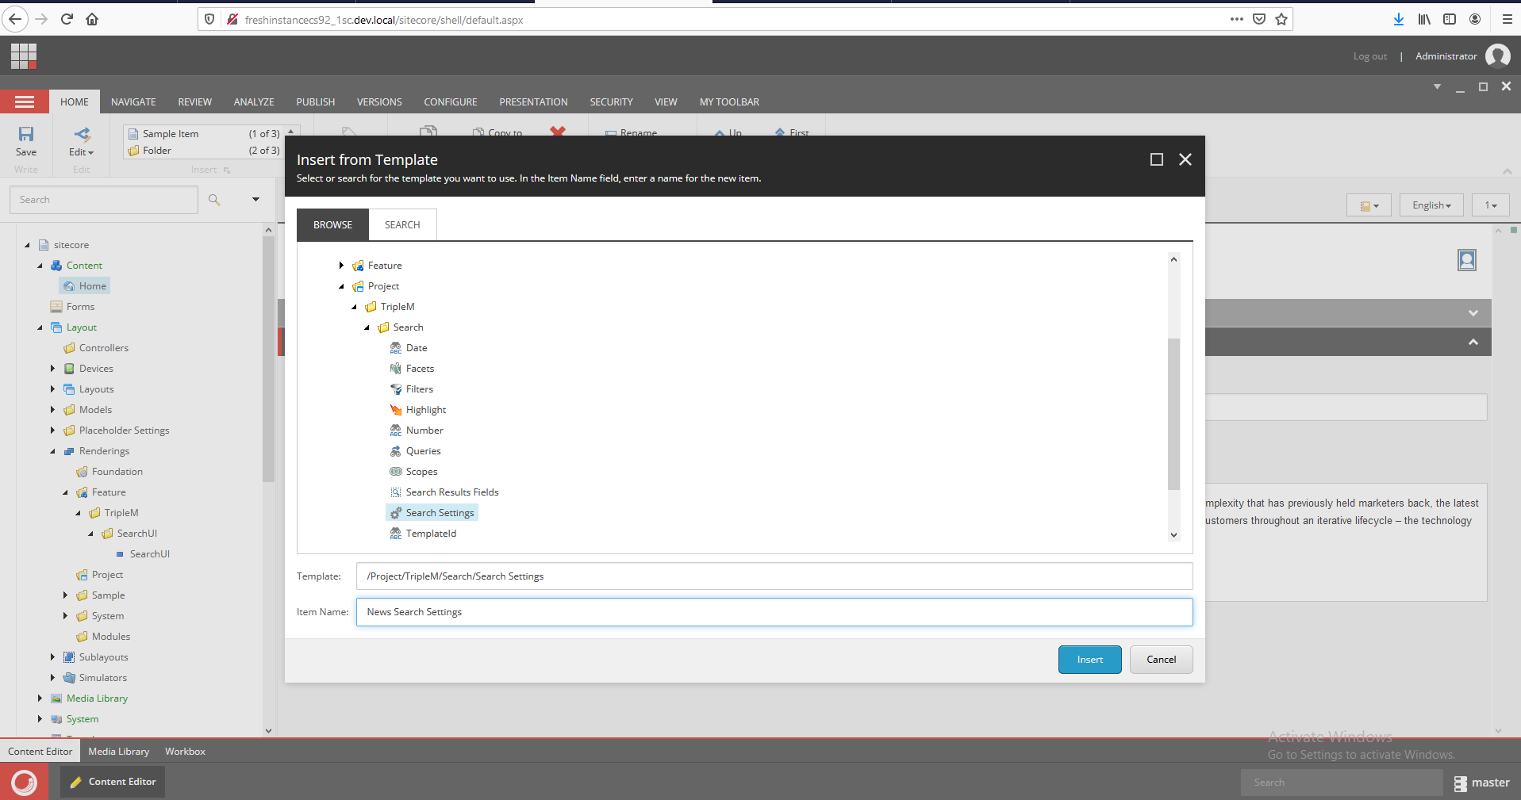  
  
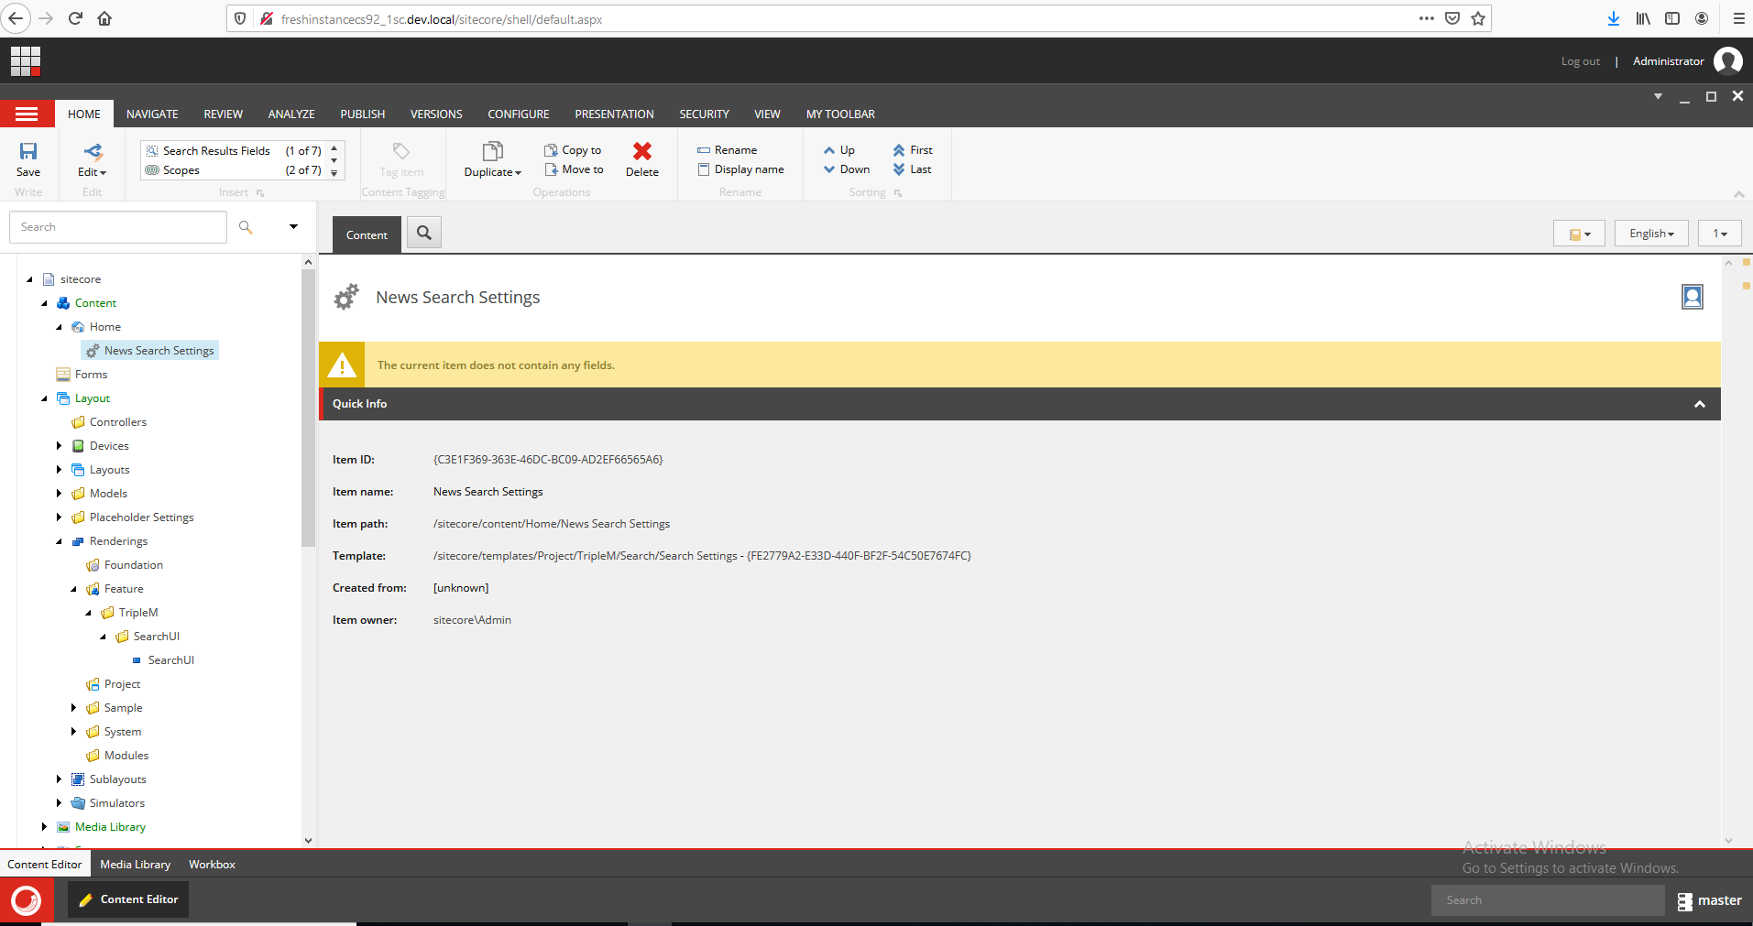

Let’s assume we have the list of items and sun children under home tree that includes different types of items.   
  
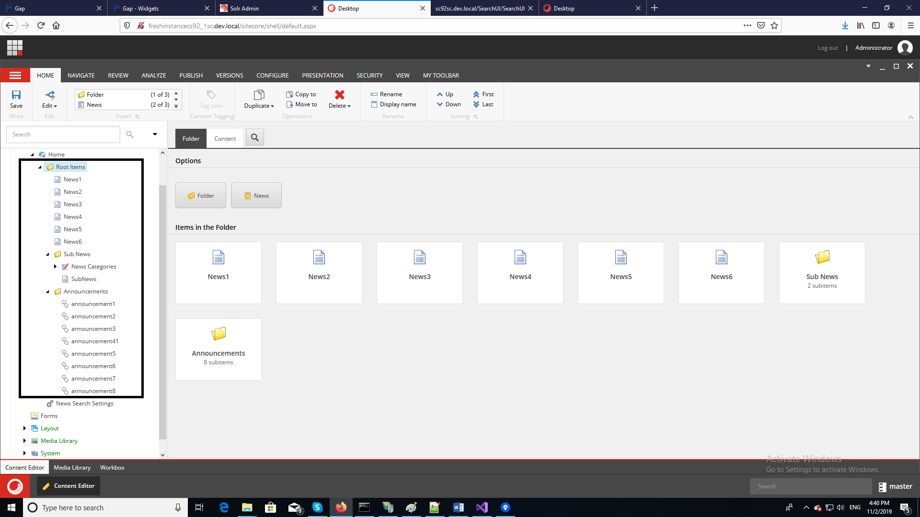

Now let’s create 5 search scenarios by using search settings as following:

* **Scenario 1**

Retrieve only all news items and sub items under root items folder and in the show result show only Name, Title and Description.

In order to get the above result, we need to create the following settings:

1- Create scopes setting and select your root item

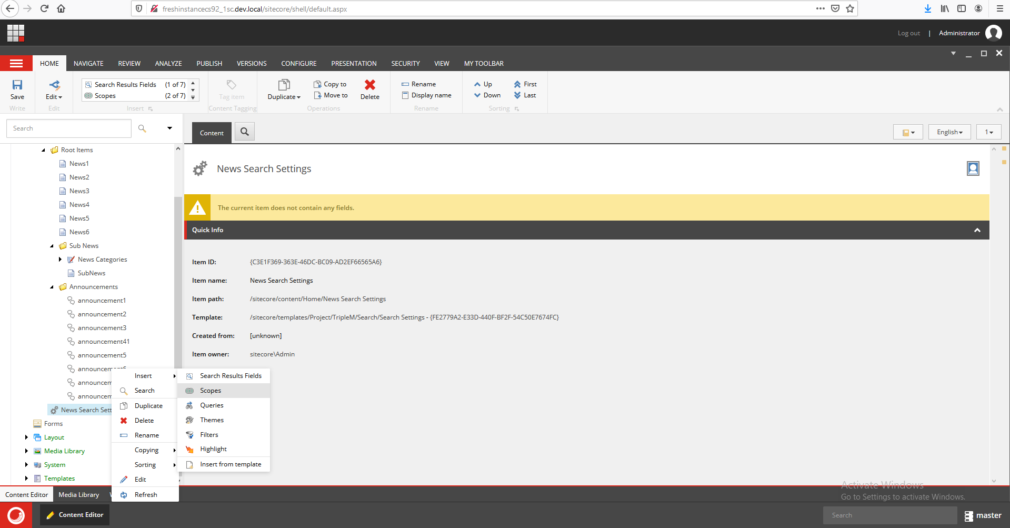

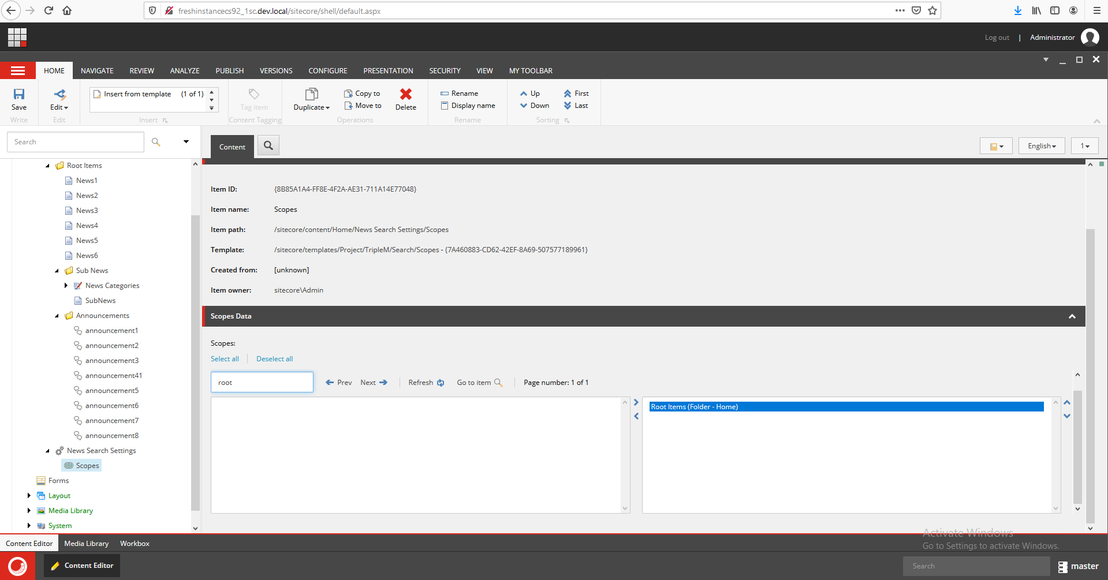

2-Create search results fields setting and file the filed name that you want to show in the result view, please make sure you write the same filed name separated by comma.  
  
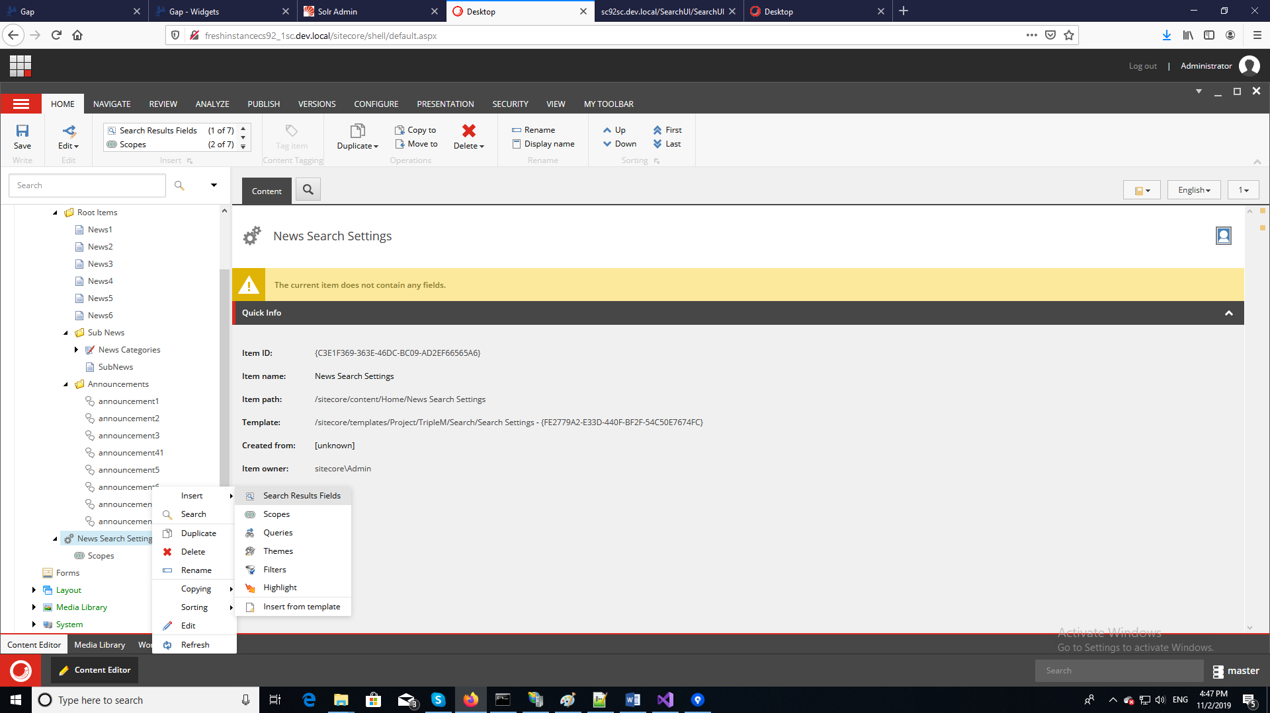

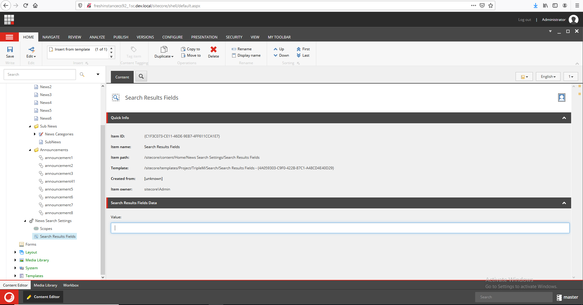

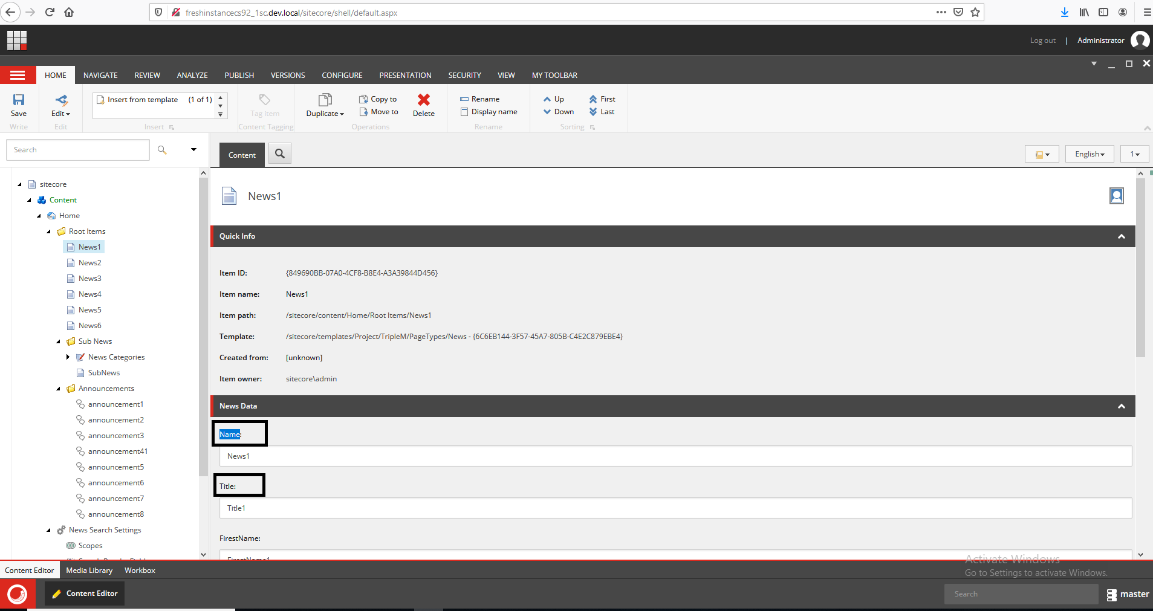

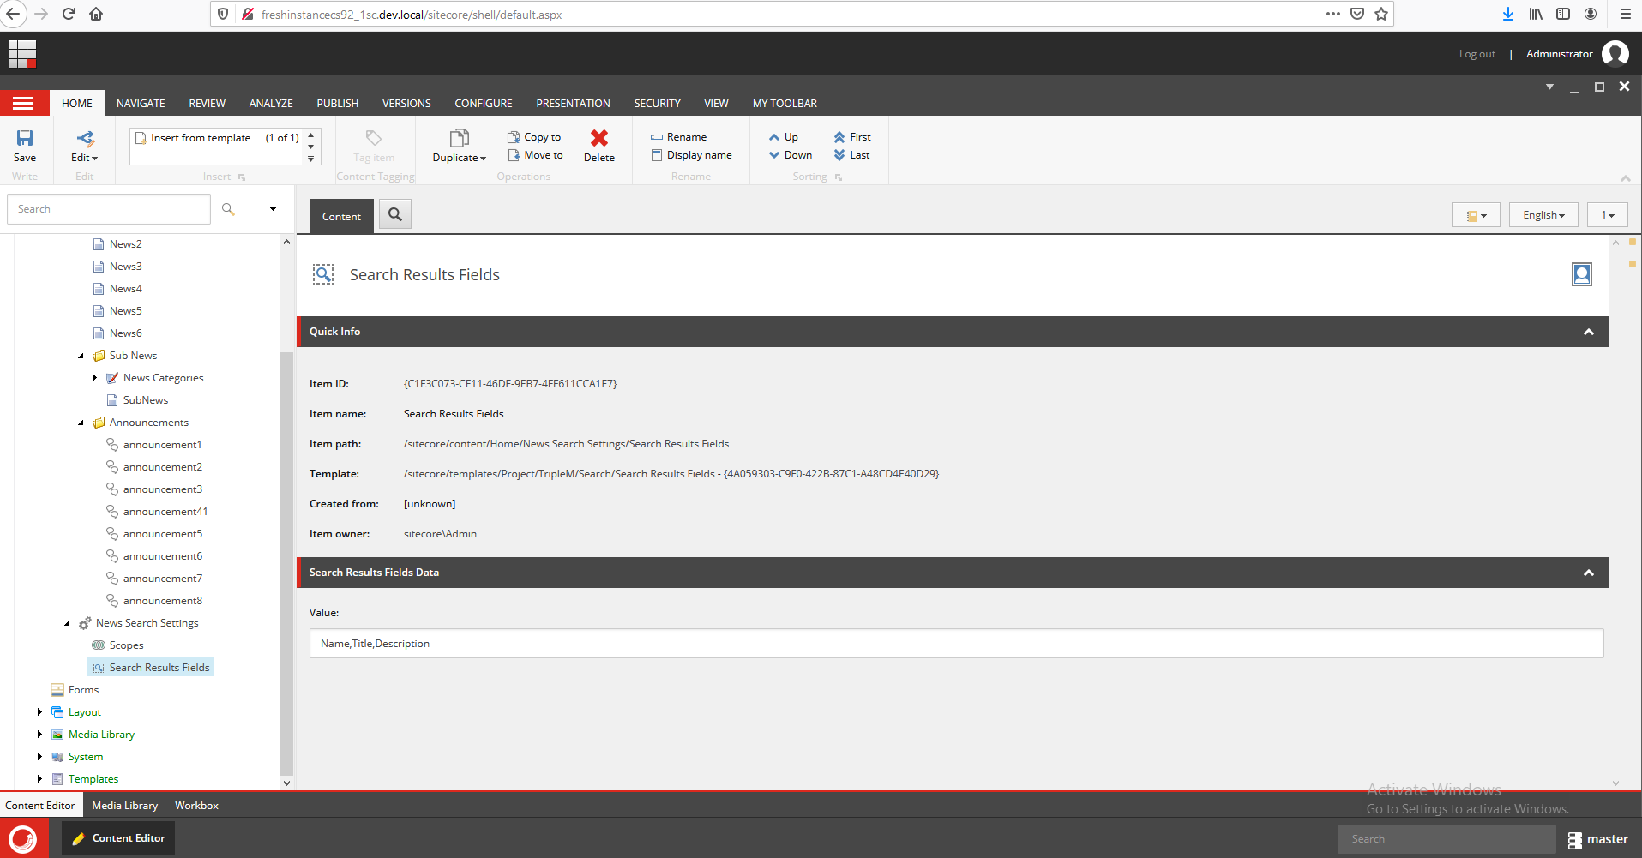

3-Create Queries setting and add new template id query to filter on the news type only  
  
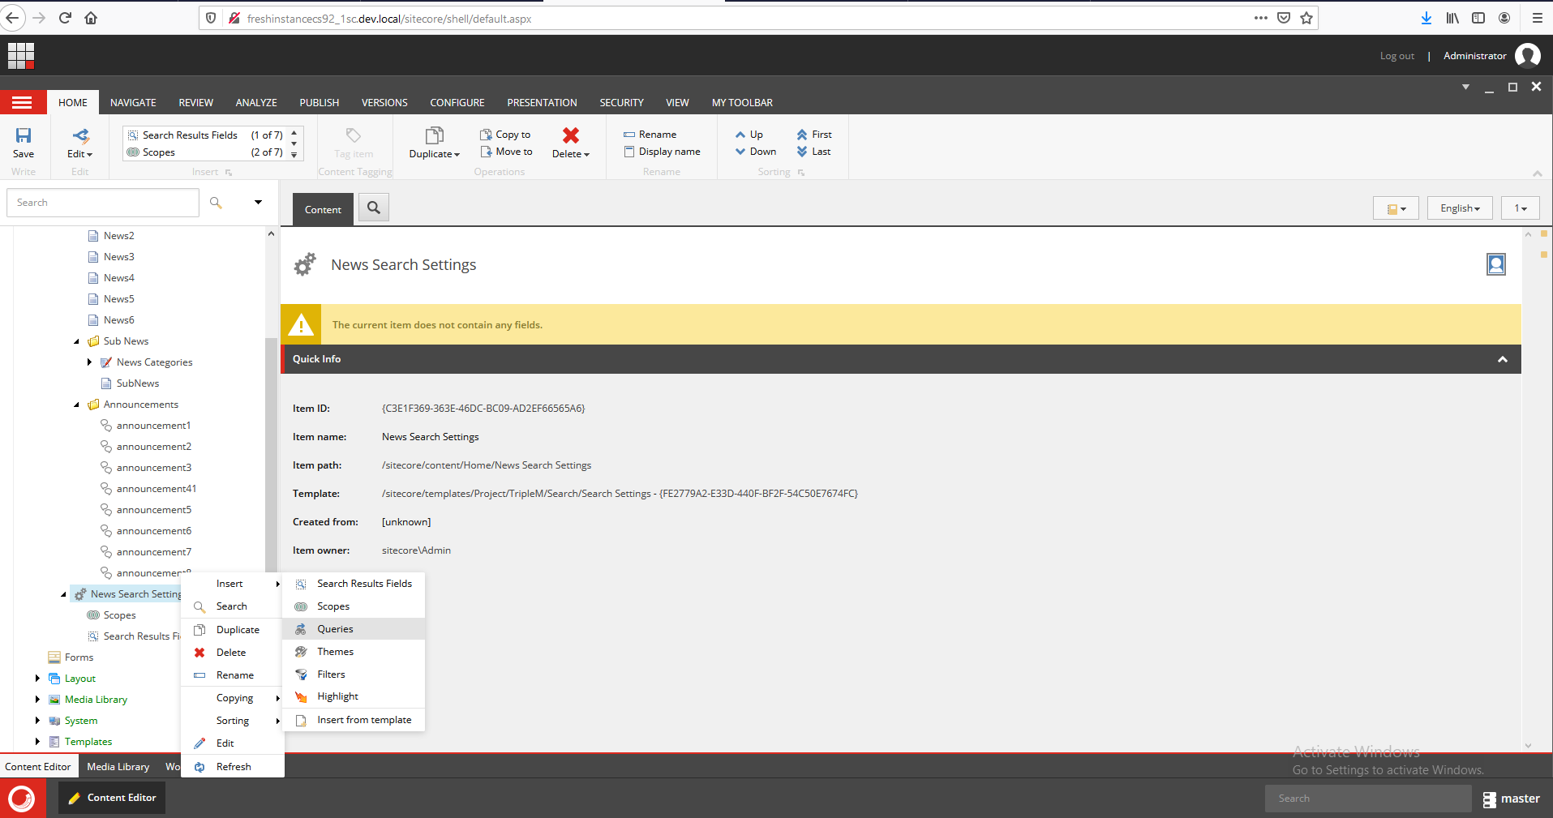

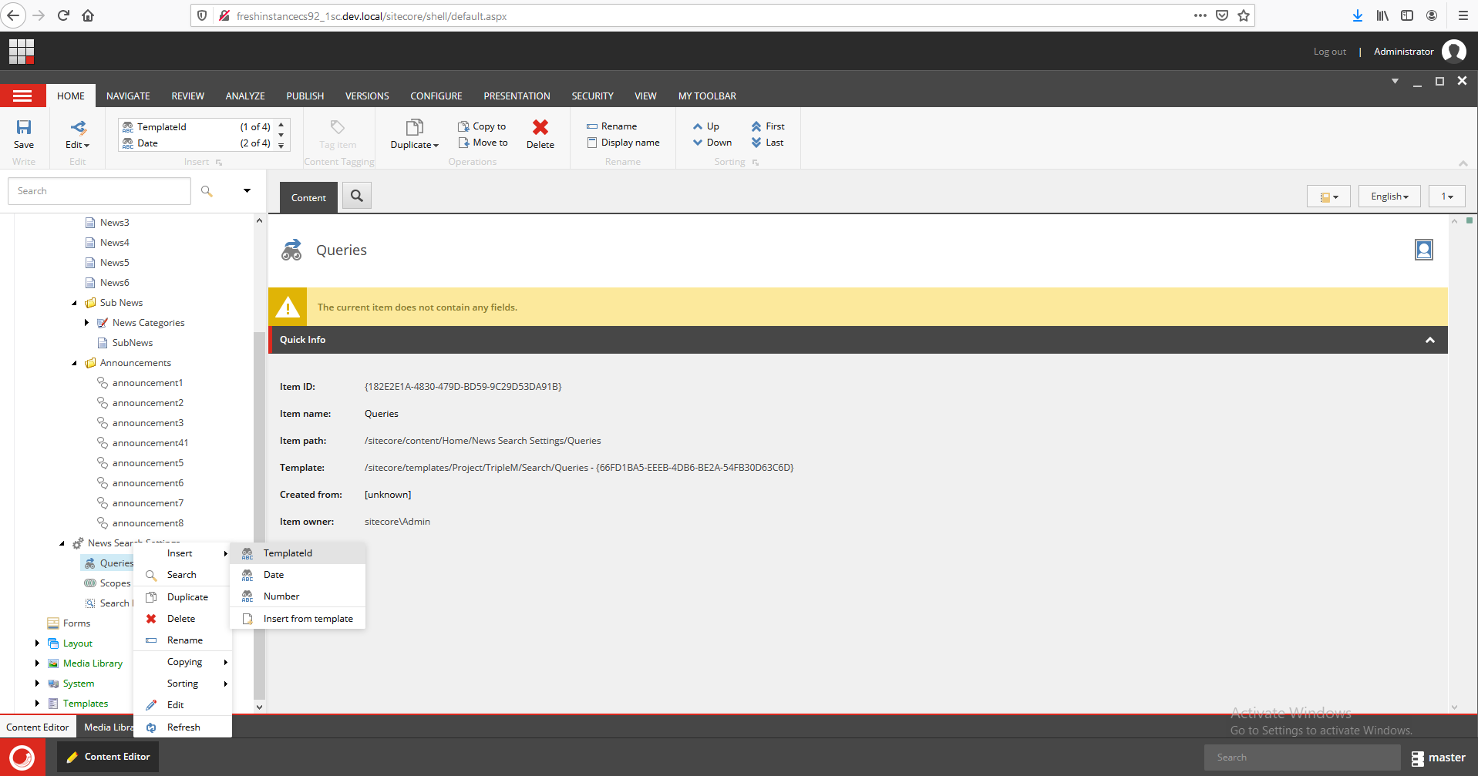

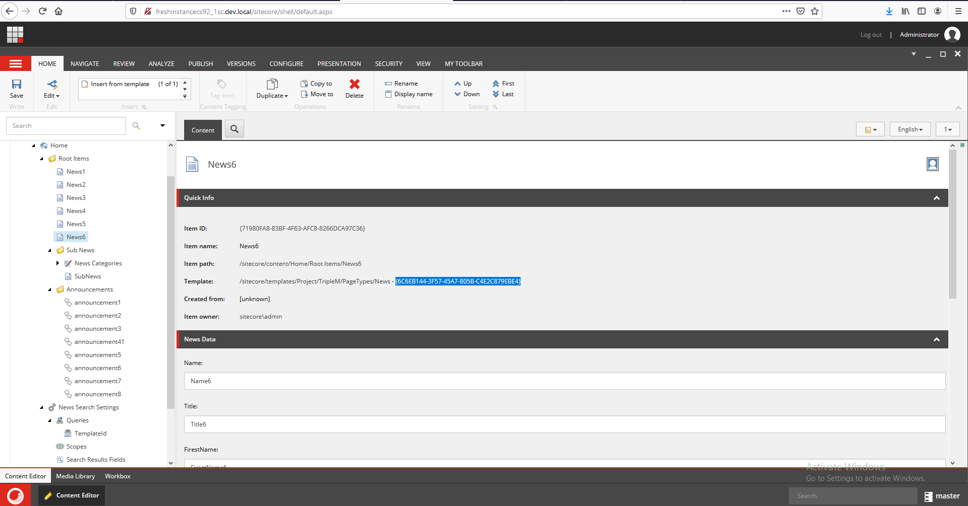

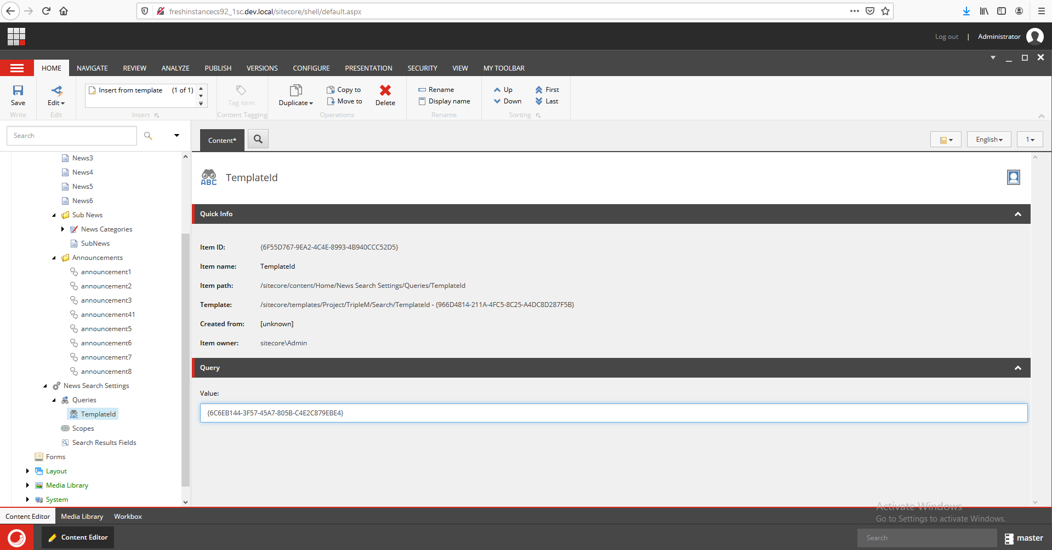  
  
  
We are done with the settings now let’s add the search rendering component to the home page and see the result.  
  
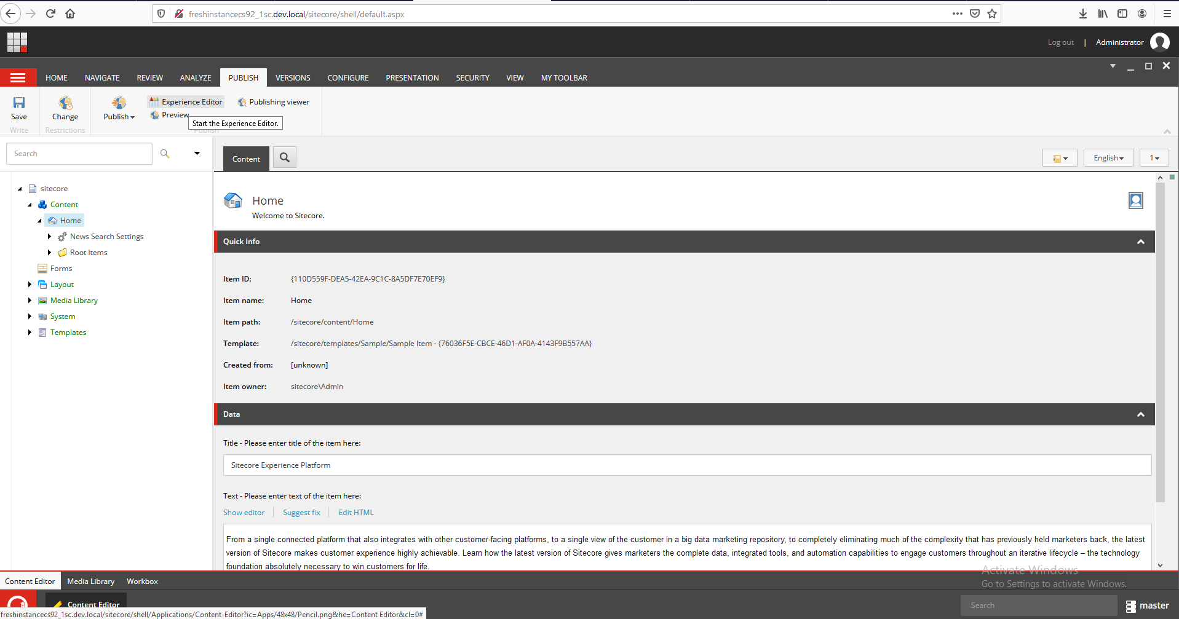  
  
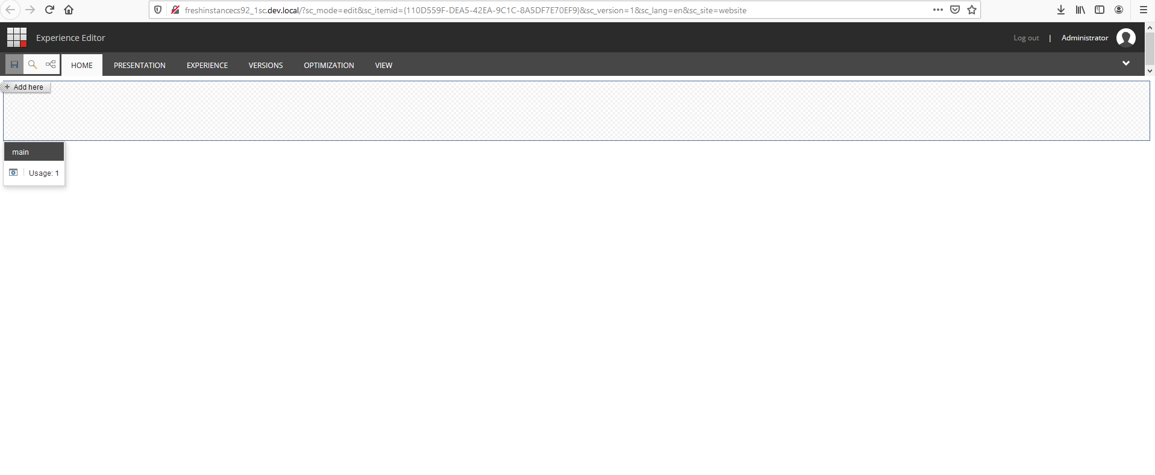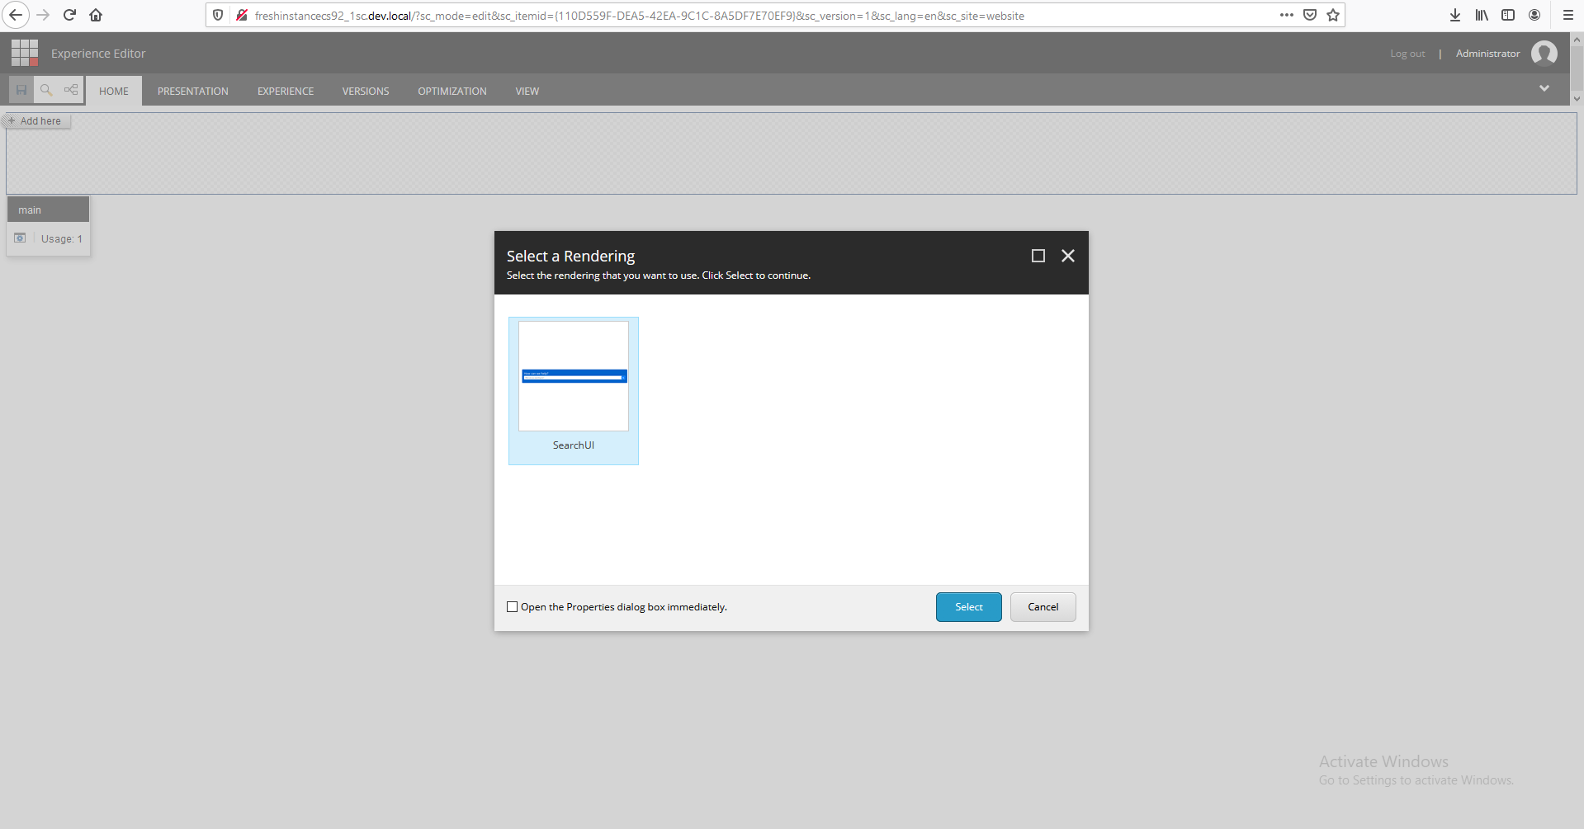  
  
  
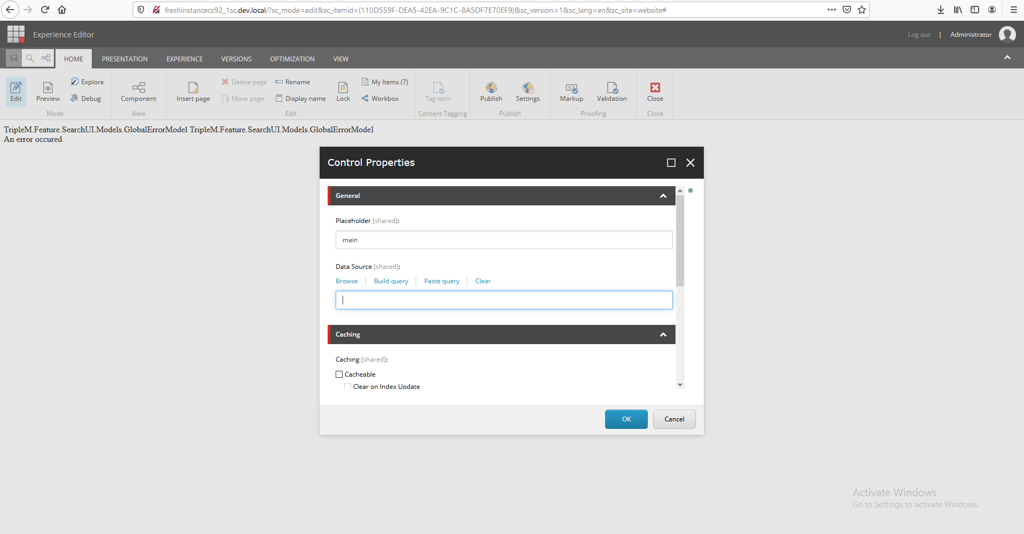  
  
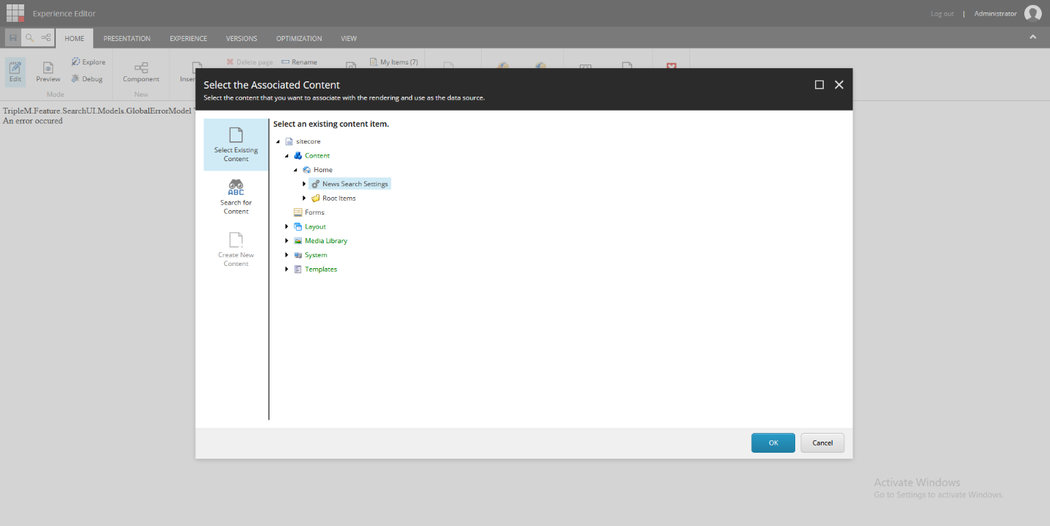  
  
  
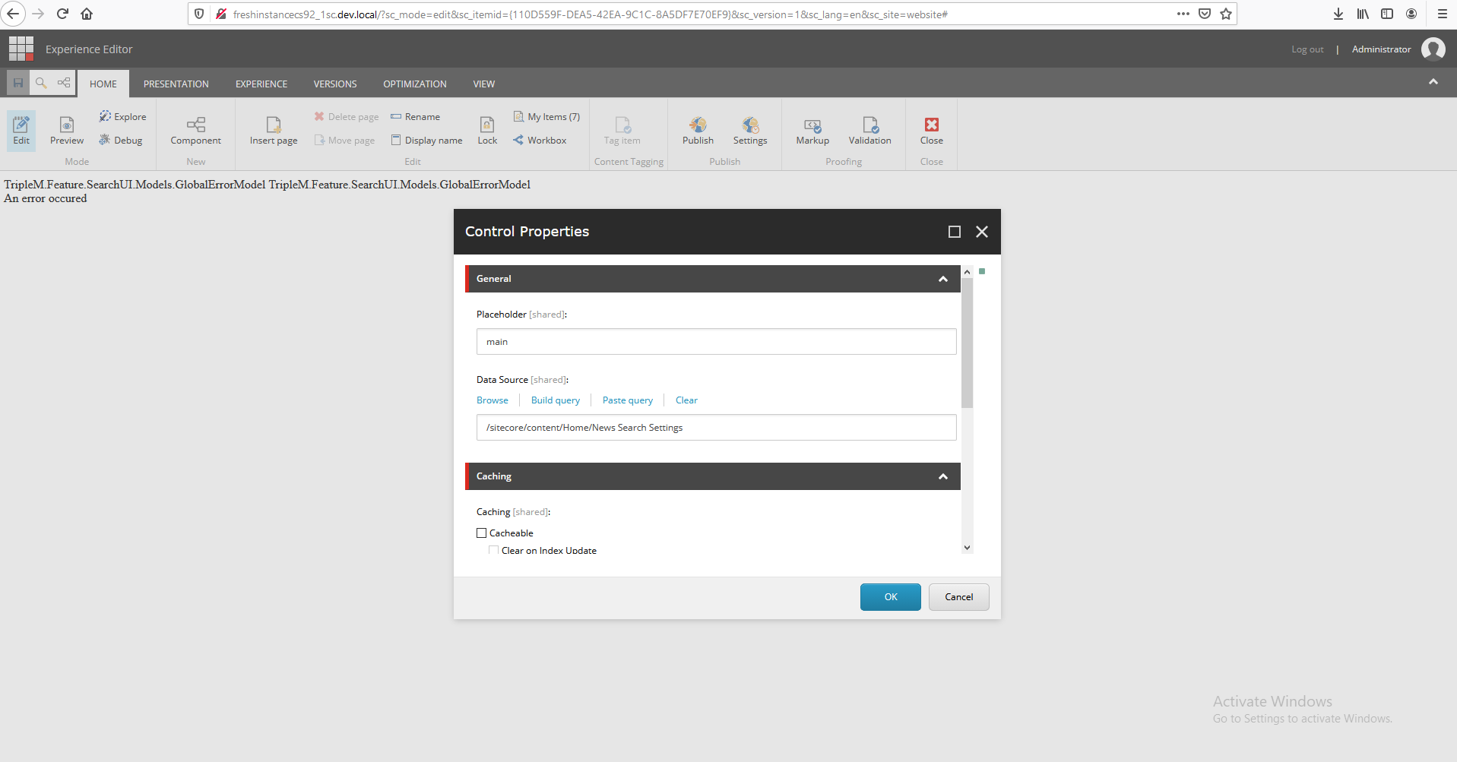  
  
  
  
  
  
  
  
In case you get this error “**Compiler Error Message:** CS1525: Invalid expression term '.”  
Please make sure your web.config has the “DotNetCompilerPlatform”

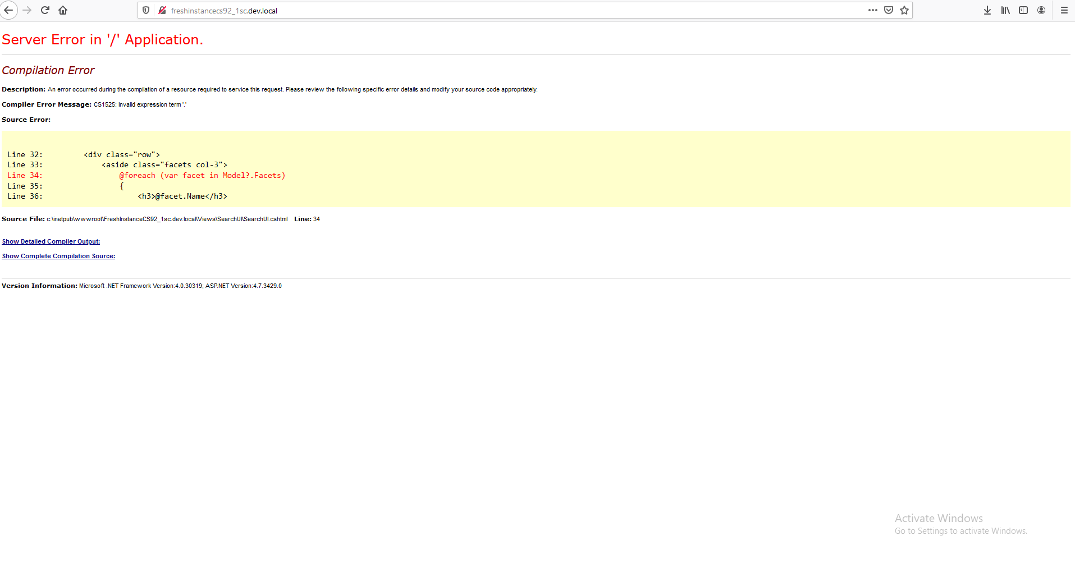  
  
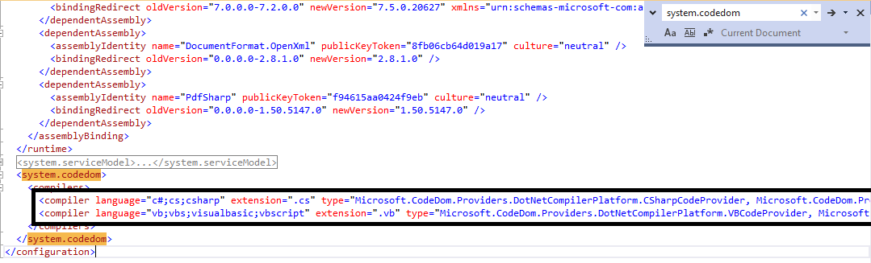  
  
Finally you will get the expected result based on the above scenario ☺

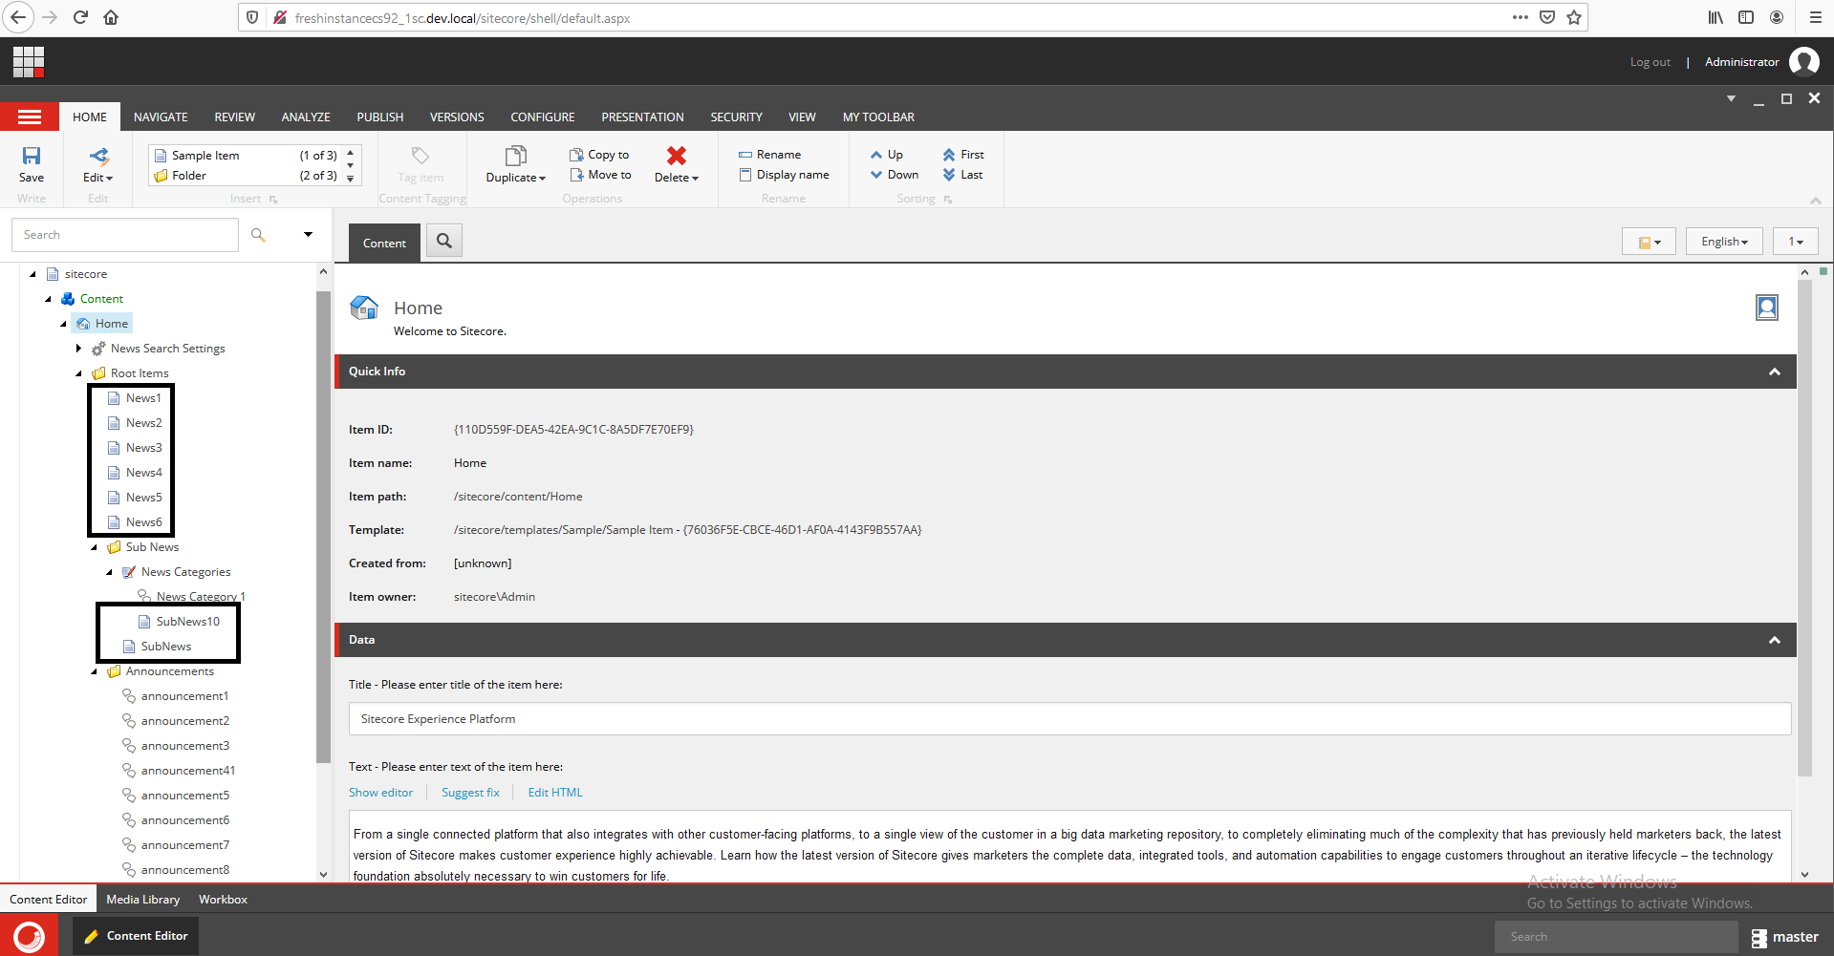

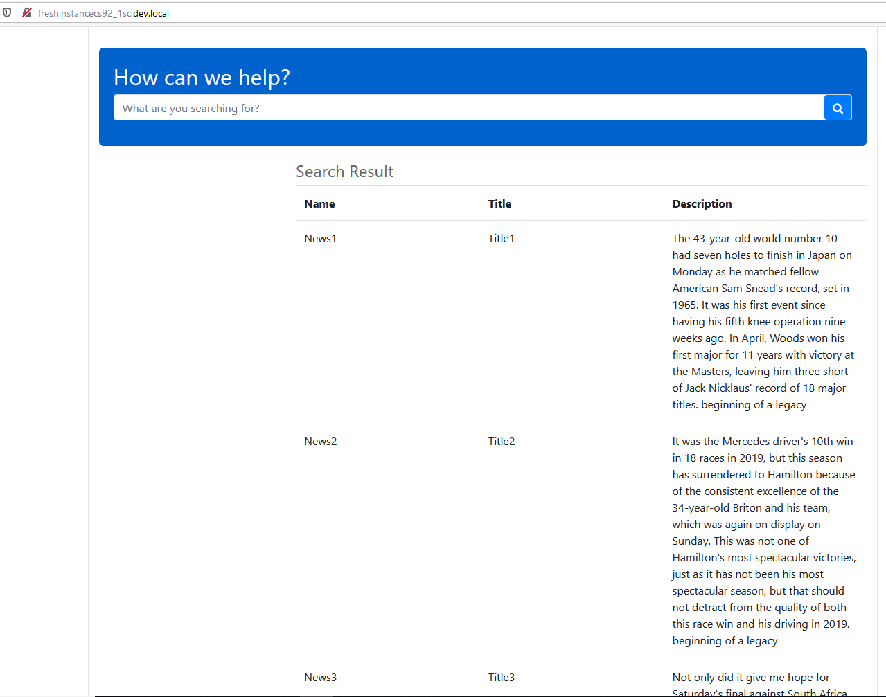

* **Scenario 2**

Retrieve only all news items and sub items under root items folder and in the show result show only Description if the news date filed is greater or equal 10/19/2019

1. Change the Search Results Fields setting to have only the Description Field

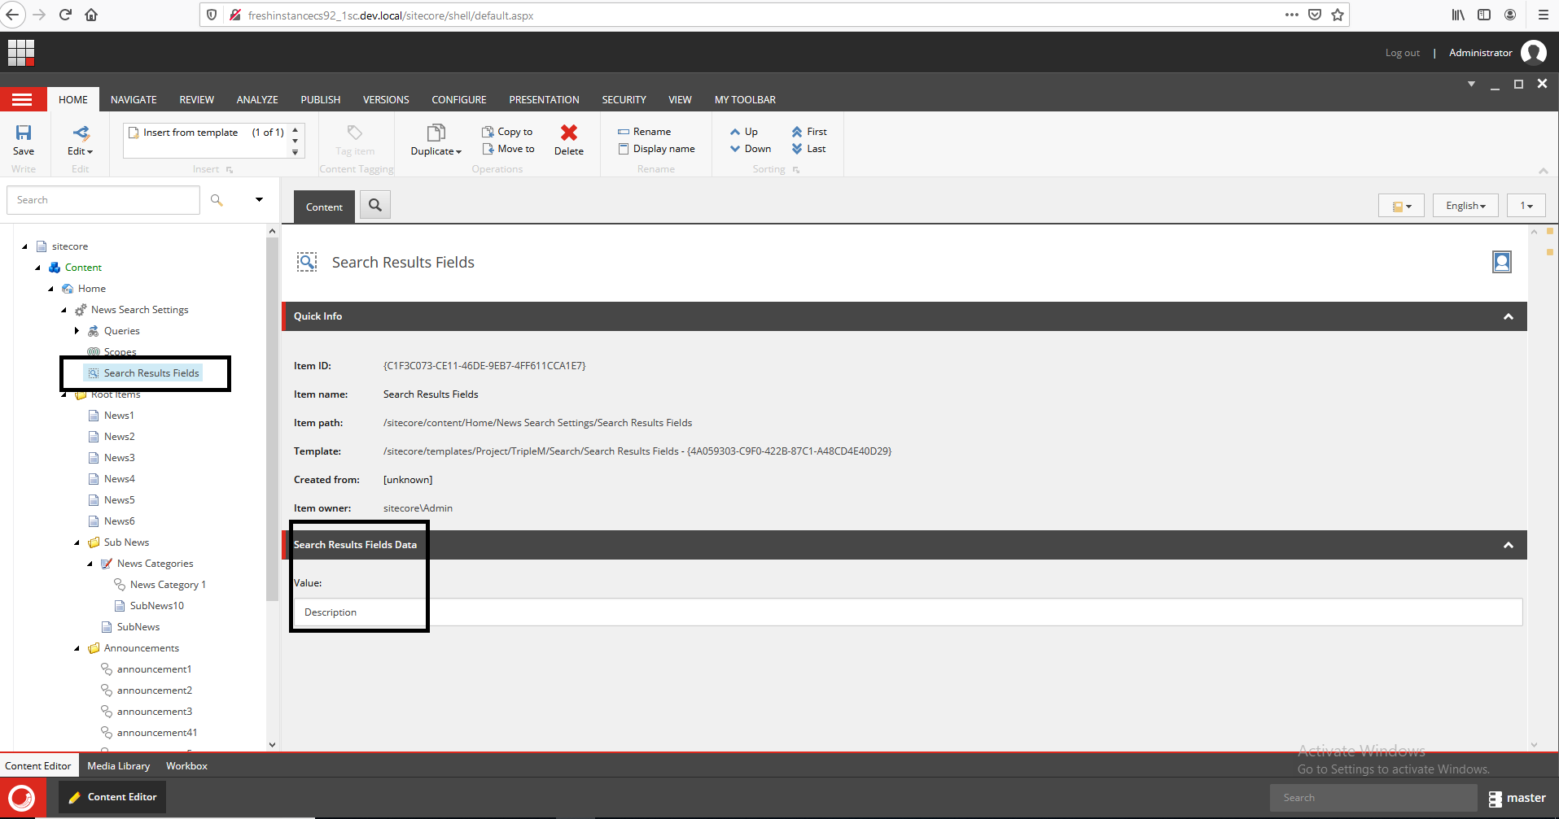  
  
  
2- Create new Date Query and write your operator query by following this pattern   
  
{filed name} {operator} {date value}  
EX: CustomDate >= 10/19/2019  
  
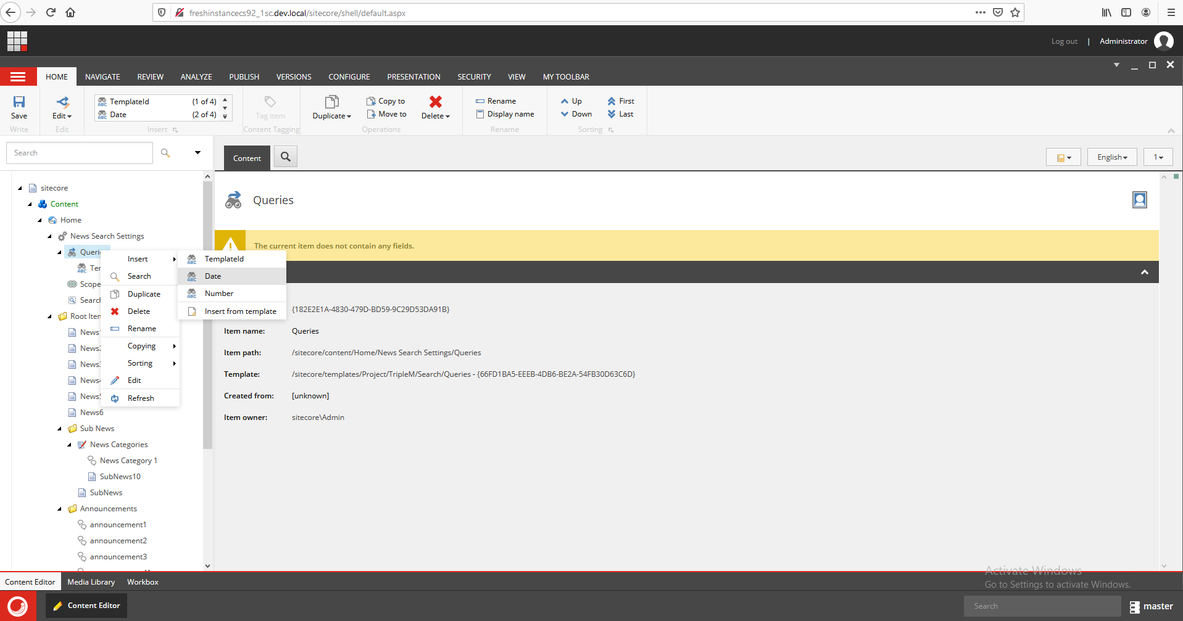  
  
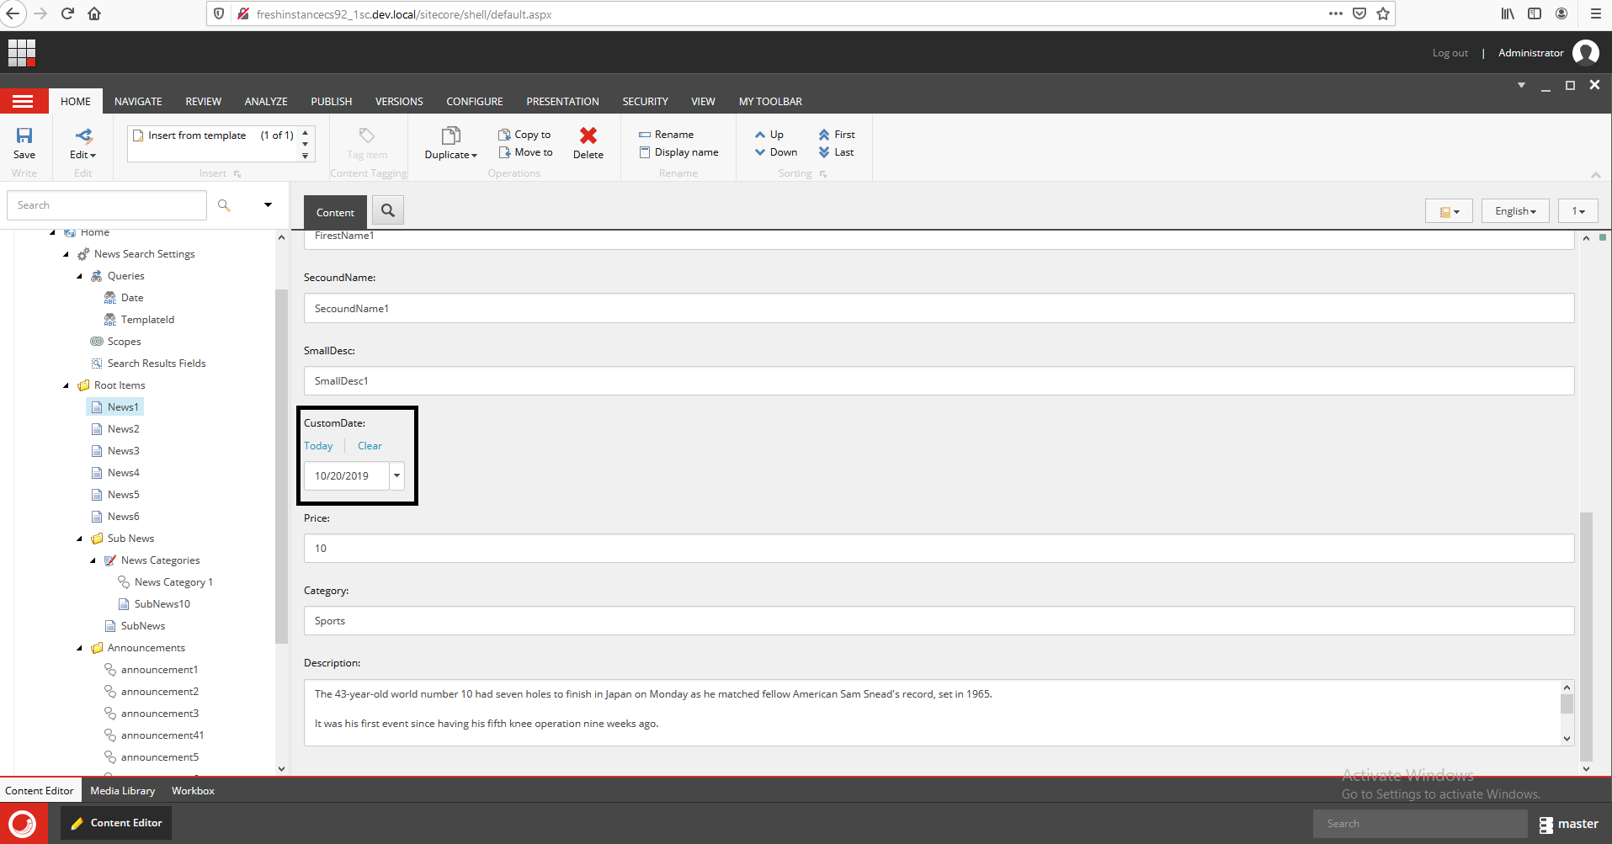  
  
  
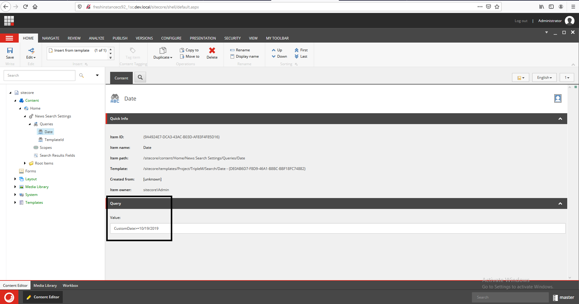

* Run the page again and you will get only 3 result based on the provided date  
    
  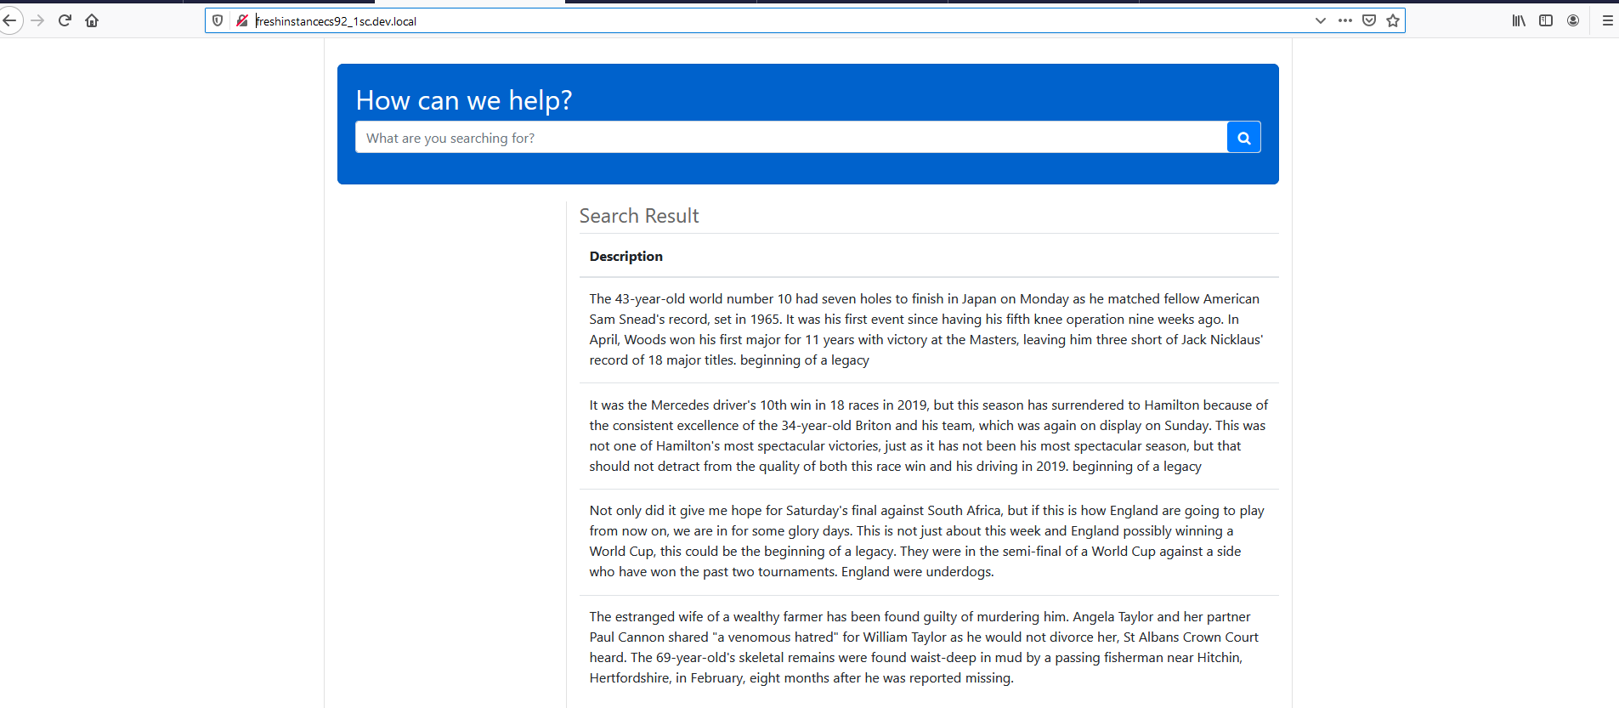  
    
    
  Let’s try to change one of the news date and refresh the page again   
    
  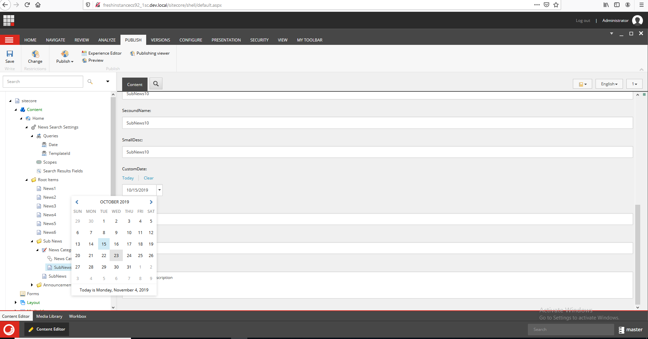  
    
    
  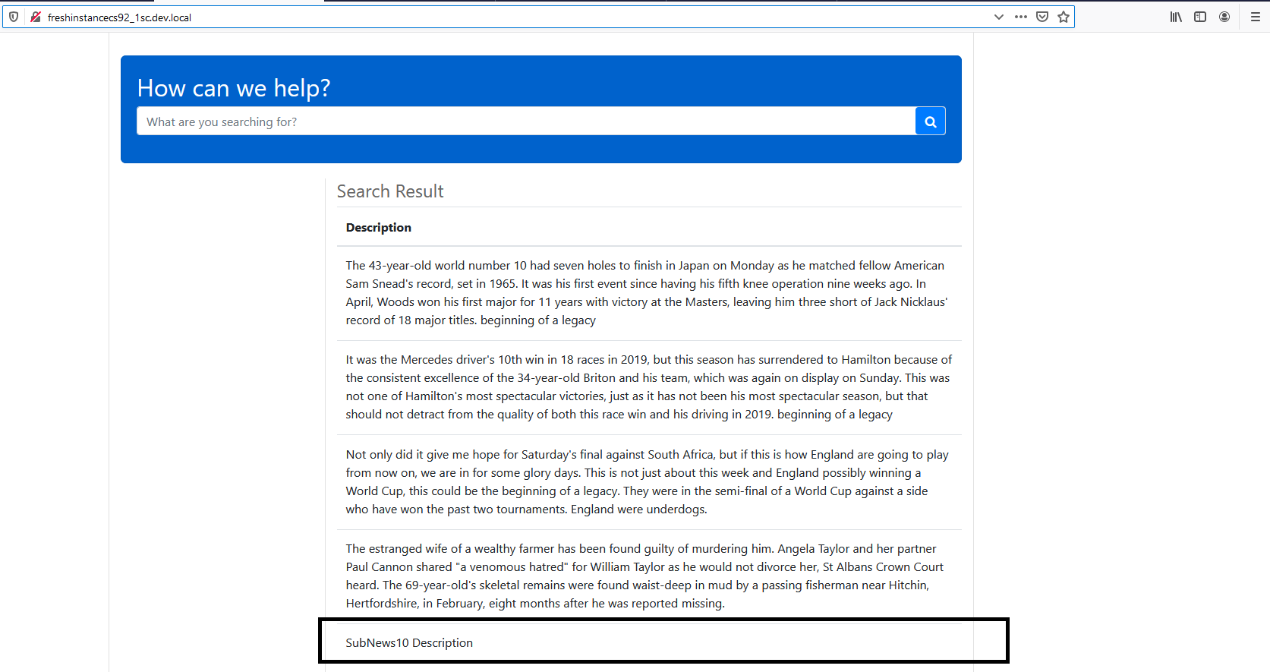  
    
    
    
    
  **Scenario 3**

Retrieve only all news items and sub items under root items folder and in the show result show only Description if the news date filed is greater or equal 10/19/2019 and the news price equal to 10

Create new Number query and write your operator query by following this pattern   
  
{filed name} {operator} {price value}  
EX: Price= 10  
  
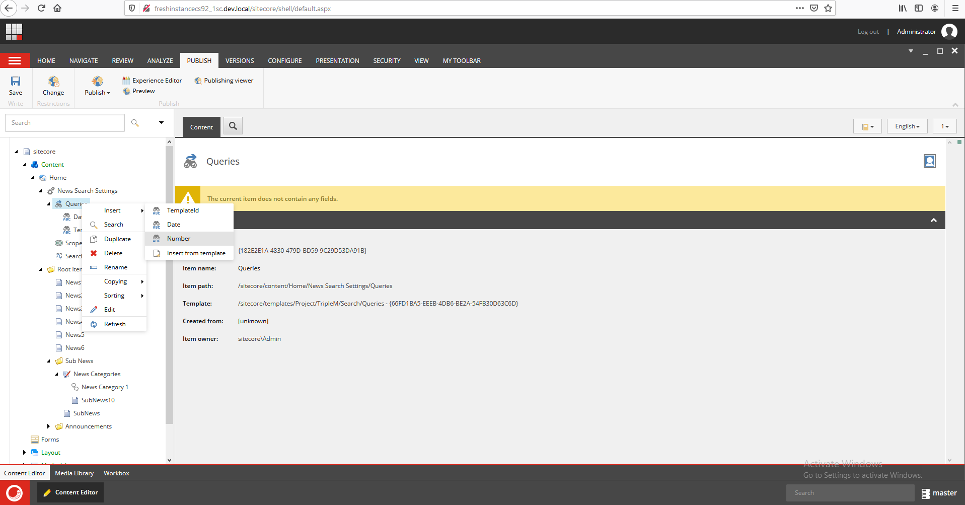  
  
  
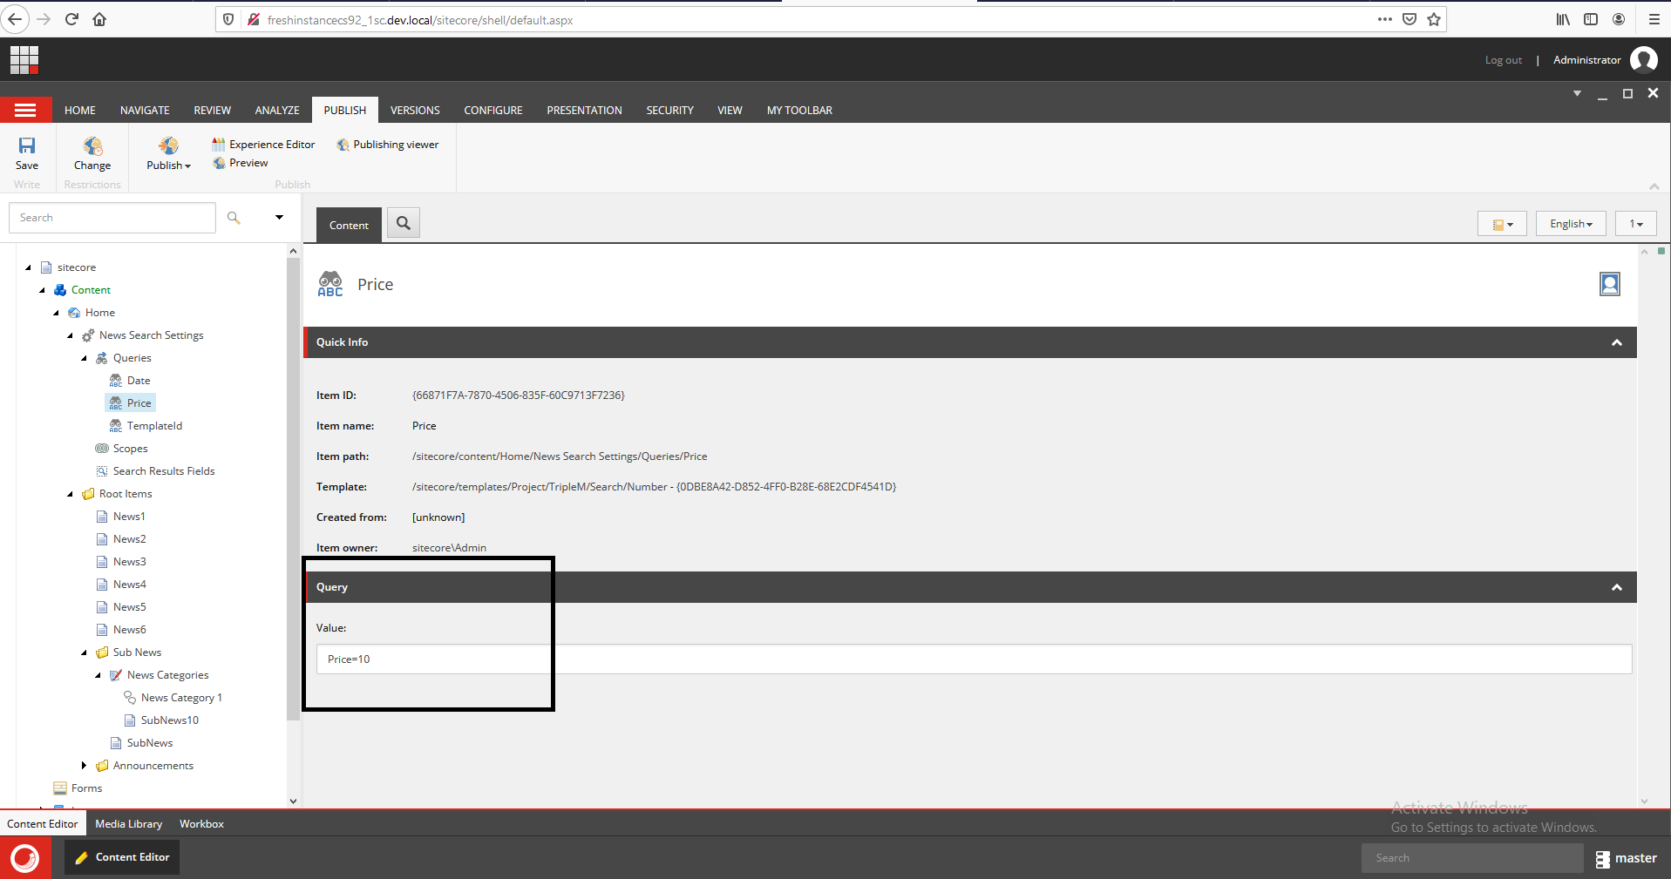  
  
  
  
**Scenario 4**Retrieve only all news items and sub items under root items folder and in the show result show only Description if the news date filed is greater or equal 10/19/2019 and the news price equal to 10 and filter on them based on news Category.  
  
1- Create new facets (filters) setting   
  
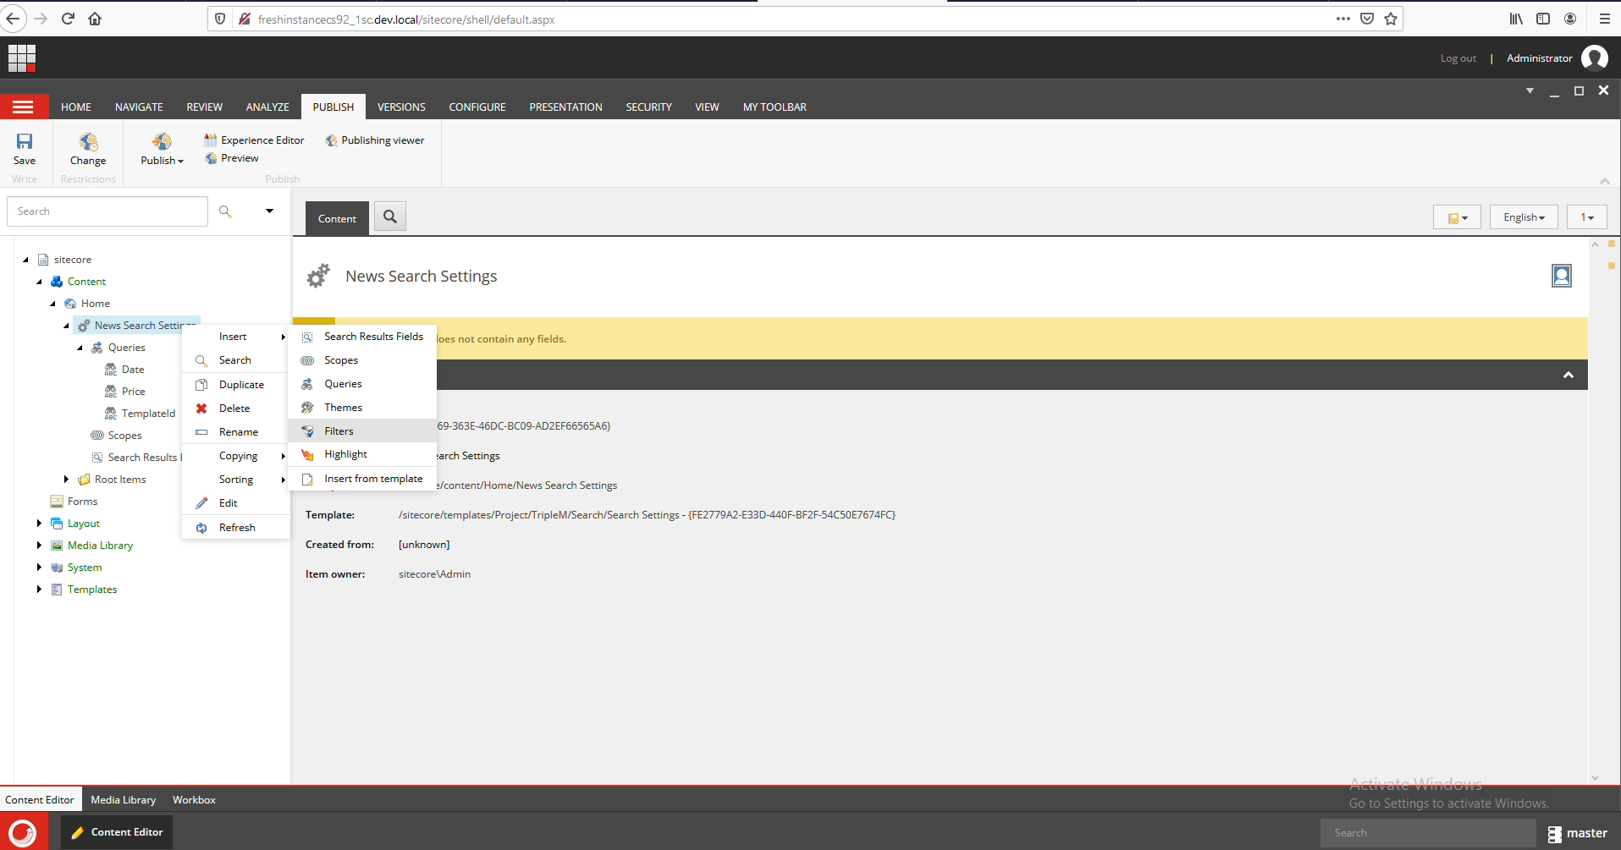  
  
 2- Add new facets based on news category filed   
  
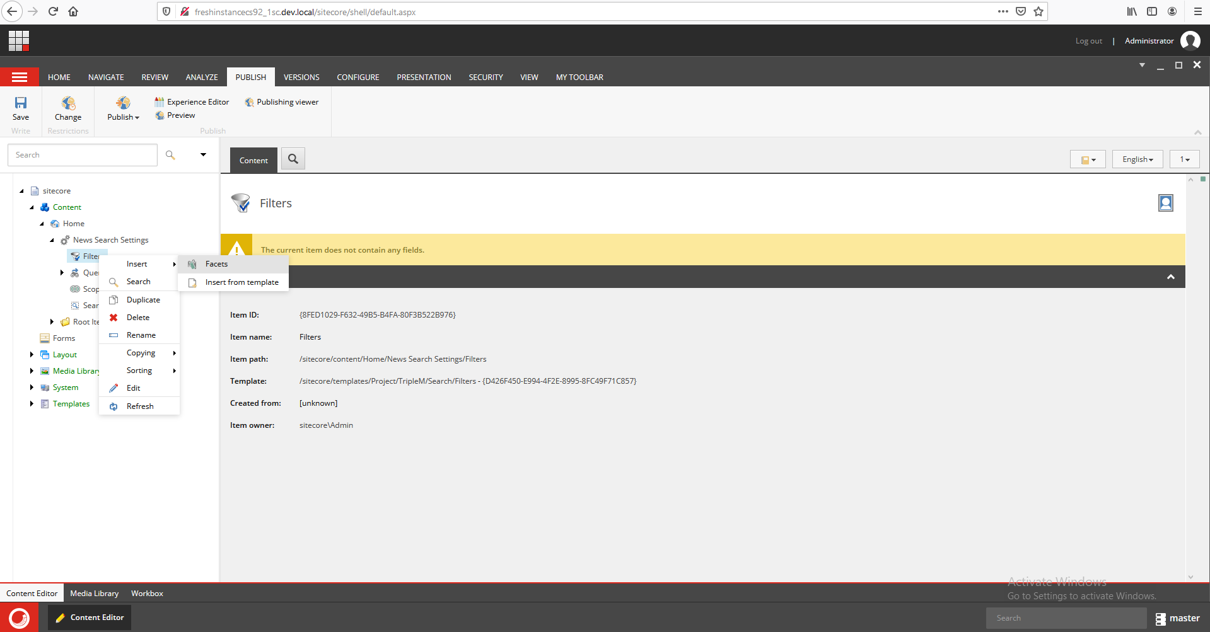  
  
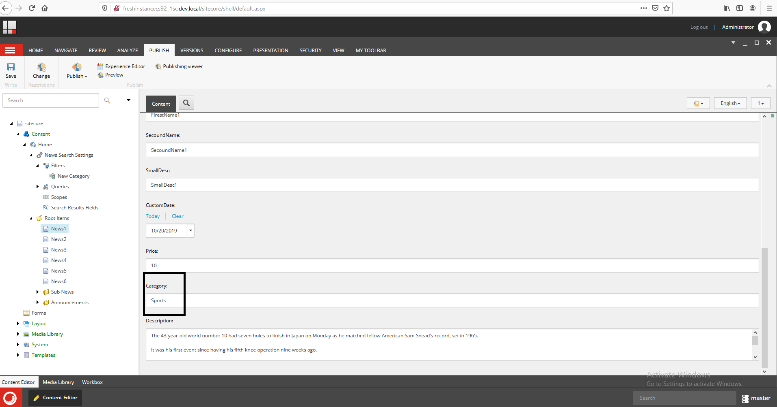  
  
  
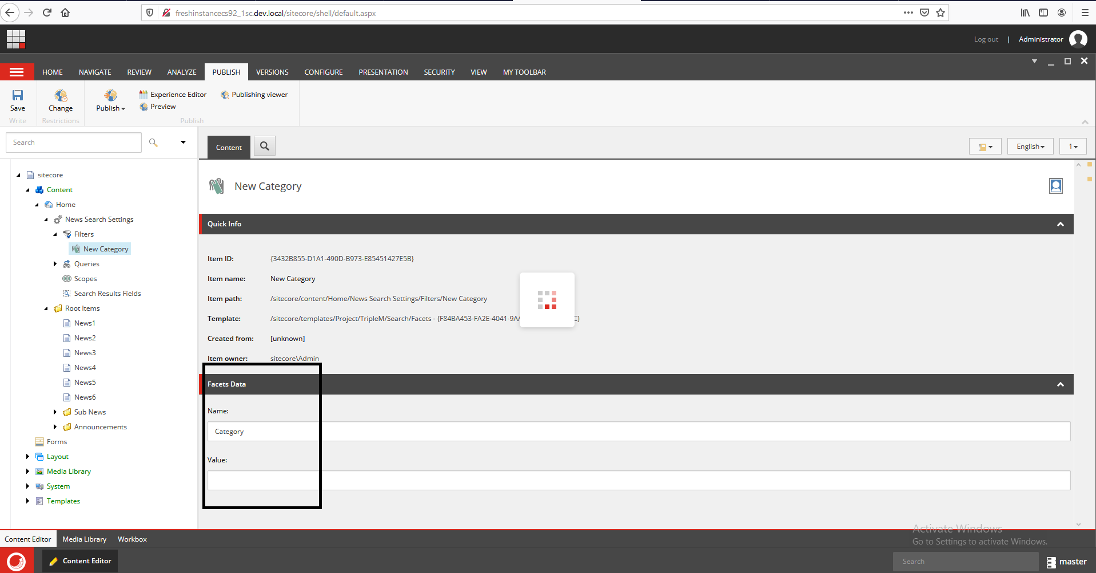  
  
  
Refresh the page and see the result ☺  
  
  
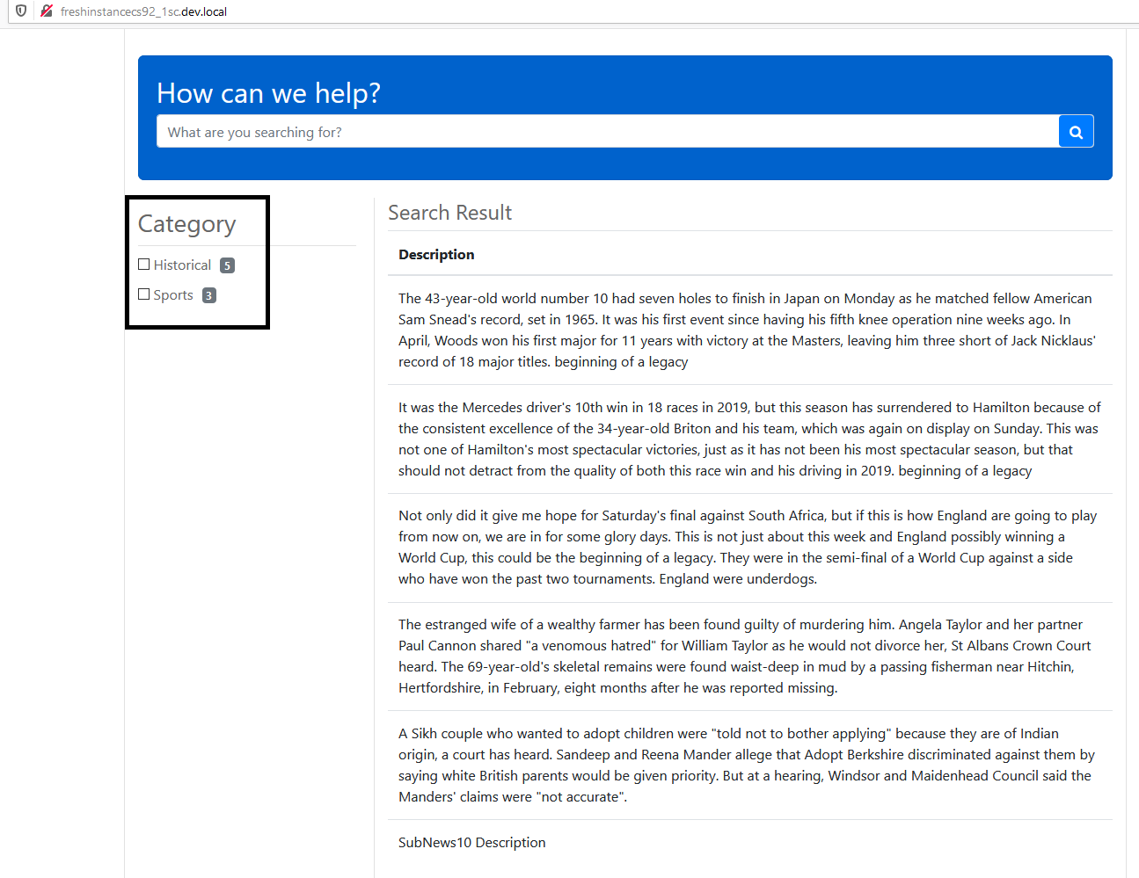  
  
  
  
**Scenario 5**

Multiple Partial Word Query , you can search for multiple word

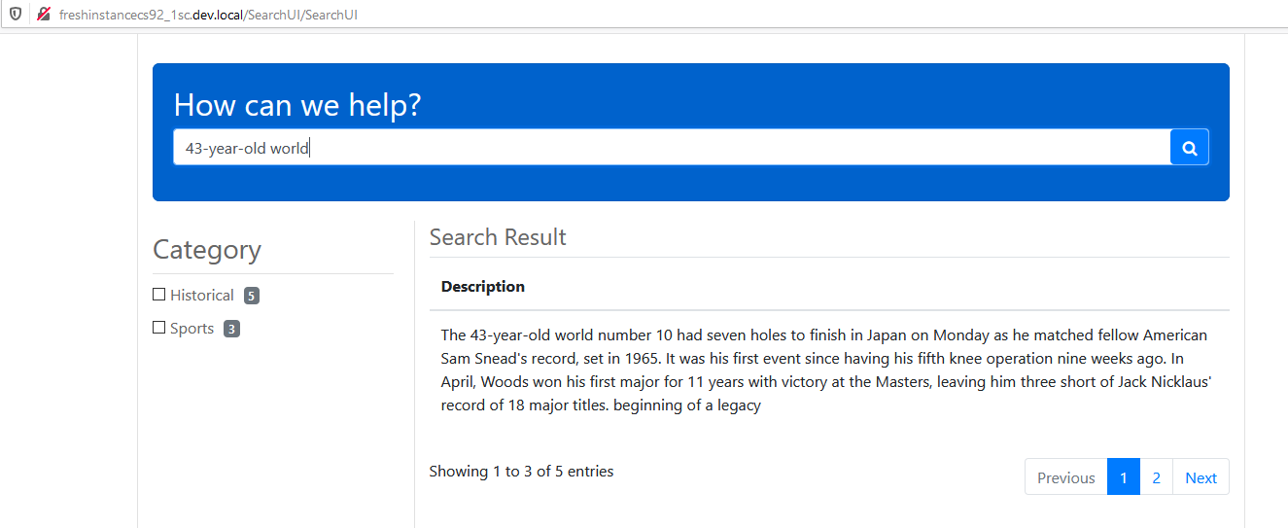  
  
  
  
**Scenario 6**Multiple Partial Word Query with Highlight Query  
  
1- Create new Highlight Query and set the value to true  
  
